

THE PREVENTION OF MONEY LAUNDERING AND FINANCING OF TERRORISM

Manual of procedures

User manual

Versión 1.0

This page does not contain any information
Contents
Contents

Chapter 1. About the document 5
1.1. Purpose of the document 7
1.2. How to use this manual 7
1.3. Classification 8
1.4. Document template 8
1.5. Contacts on document 8
1.6. Document history 8
Chapter 2. Introduction and mandatory framework 9
2.1.General information 11
2.2. Definition of Money Laundering 12
2.3. Definition of Terrorism Financing 13
2.4. Asset laundering stages 14
2.5. Definition of prevention of money laundering and financing of terrorism 18
2.6. International regulations 18
2.7. Brazilian regional regulations 19
Chapter 3. The PMLFT system 23
3.1. General information 25
3.2. Content of the PMLFT system 25
3.3. Business Relationship Acceptance Policy 26
3.4. Procedures for the identification and knowledge of clients 26
3.5. Customer risk categorization policies 28
3.6. Know Your Customer Policy 35
3.7. Policy for monitoring and reporting of suspicious operations 43
3.8. Confidentiality, database and audit 48
3.9. Know Your Employee Policy 49
3.10. Organizational structure 53
3.11. Independent review of the comprehensive PMLFT system 57
Chapter 4. Annexes 59
4.1. Terms and abbreviations 61
4.2. References to external documents 64
4.3. Board minutes: PMLFT approval 65
4.4. Customer contract 66
4.5. External review of the procedures of the PMLFT of Migom Company 67
4.6. Employee’s Registry 68
4.7. Customer registration form. Corporate customers 69
4.8. Declaration form of the beneficial owners of the company 71
4.9. Declaration form of the funds origin 72
4.10. Suspicious transaction report 73
4.11. Declaration form of the verification the veracity of the data provided 76
4.12. Declaration form of the risks evaluation 80
4.13. The countries which have signed the Memorandum of Understanding and are presently members of CFATF and the 6 Co-operating and Supporting Nations 85

This page does not contain any information

CHAPTER 1. About the document

Chapter 1. About the document

This chapter consists of the following sections

Section | Description | Page
1.1. | Purpose of the document | 7
1.2. | How to use this manual | 7
1.3. | Classification | 8
1.4. | Document template | 8
1.5. | Contacts on document | 8
1.6. | Document history | 8

This page does not contain any information

1.1. Purpose of the document

This document describes the actions of the employee of the BLOX PAYMENTS SOLUÇÕES EM MEIOS DE PAGAMENTOS LTDA. for the prevention of money laundering and financing of terrorism (PMLFT).
The objectives of this document are:
- To help prevent the possible execution of transactions with funds of criminal origin that use the Company as a vehicle for money laundering;
- To facilitate the recognition and reporting of unusual activities and operations that may be related to Asset Laundering;
- To minimize the risks of loss of image and reputation of the Company;
- To inform the staff of the legal and administrative regulations in force in this matter, promoting and controlling their compliance;
- To help avoid possible civil, criminal and/or economic sanctions for both the Company and its employees and officers;
- To publicize the commitment assumed by the Company in the fight against Asset Laundering and Terrorist Financing;
- To apply a Know Your Customer policy reaffirming the need to reliably identify our customers by identifying their final beneficiary;
- To report to the Financial Intelligence Unit “suspicious operations” in the cases in which it corresponds. (Anti-Money Laundering and Suppression of Terrorist Financing Code of Practice, 2014, FIU and Federal low of Brasil Law 12,683/12 of July 9, 2012).
This document was prepared by specialists working with clients and contains confidential information.

1.2. How to use this manual

The manual is designed to provide you with a useful reference tool for all information related to the Company employee actions for the prevention of money laundering and financing of terrorism (PMLFT).
At the end of the document, terms and abbreviations and references to other documents on the use of PMLFT standards are attached.
Terms and Abbreviations - a glossary of terms commonly used in PMLFT.

1.3. Classification

This document has been classified as Internal.

1.4. Document template

100101

1.5. Contacts on document

In the case of questions or proposals regarding the information presented in this document, you can contact the Documentation Division of the Migom Company by email docs@migom.com, by phone + Tel: +1 767 448 4297 or by mail, using the address: 75 Hillsborough Street Roseau Commonwealth of Dominica.

1.6. Document history

Version Date Modification Notes Authors

1.0 01.07.2022 - Init. version Fedor Bogorodskiy

chapter 2. Introduction and mandatory framework

Chapter 2. Introduction and mandatory framework

This chapter consists of the following sections

Section | Description | Page
2.1. | General information | 11
2.2. | Definition of Money Laundering | 12
2.3. | Definition of Terrorism Financing | 13
2.4. | Asset laundering stages | 14
2.5. | Definition of prevention of money laundering and financing of terrorism | 18
2.6. | International regulations | 18
2.7. | Brazilian regulations | 19

This page does not contain any information

2.1.General information

In this chapter we provide the main information on the procedure for the prevention of money laundering and financing of terrorism in the Company in compliance with the applicable regulations.
Migom Company is a Company, operating in the international market, which has as its objective the banking services providing both for the individual and corporate customers through the Internet and in their branches.
The Company's main asset is its reputation, basing its actions on integrity, professionalism and ethical principles. For this reason, it is essential for the entire Company that it stay away from any illicit activity, especially those such as Money Laundering and Terrorist Financing.
The behavior of the directors, senior staff and employees of the Company regarding the prevention and detection of criminal activities is based on the rules of conduct contained in the Code of Conduct for the Company, approved by its Board of Directors.
These regulations will apply to the Company and will be binding on all its employees and directors.
The content of the Regulation will prevail over that of those internal regulations that could contradict it, except that they establish stricter conduct and/or prevention requirements.
This document can only be modified by the Legal and Compliance Area, subjecting it to the prior approval of the Company's Board of Directors.

2.2. Definition of Money Laundering

The Money Laundering Prevention low No 12,683, implemented on July 9, 2012 address specific offenses relating to dealings with the proceeds of crime.
Money laundering operations consist of the introduction into the financial system of small or large sums of money from illicit activities without their true origin being detected.
For this it is necessary to circulate the funds through different entities and jurisdictions, until any possibility of identifying the illegal origin disappears.
The ultimate goal of money laundering is the development of methods that allow laundered funds to enter the legal circuit or the reverse method, that funds considered legal enter the illegal circuit.
Within the framework of a heavily regulated financial system where, in addition, the reputation of companies operating in the international market is one of their most valuable assets, the prevention, detection and monitoring of possible operations related to money laundering is a necessity. Increasingly important.
There is no single definition of "Money Laundering", since this criminal activity adopts infinite combinations to achieve its objective. In general, when it comes to formulating a definition, it is always chosen to define the final objective pursued by this illicit activity, which consists of the "simulation of legality" of assets originating in illicit.
With this criterion, the following definitions are generally accepted:
l) Any operation, commercial or financial, aimed at legalizing resources, goods and services from criminal activities.
ll) The transformation of money obtained illegally, into patrimonial values, with the purpose of pretending that it is a legal or legitimate gain.
It is important to highlight and warn that the origin of the money applied to these illicit operations does not only come from activities directly related to internationally organized drug trafficking, but also others such as terrorism or fraud.

2.3. Definition of Terrorism Financing

Defined by the United Nations, it is understood any activity in which: “a person who by any means, illegally and of his own free will, provides and collects funds with the intention that they be used, or knowing that they will be used to carry out the Next:
- An act that constitutes an offense within the scope and as defined by existing treaties or
- Any other act intended to cause death or serious bodily injury to civilians, or to any other person not actively participating in hostilities in a situation of armed conflict, when the purpose of said act, by its nature or context, is to intimidate a population, or compel a good government or international organization to perform or refrain from performing an act”.
At the national level it defines the terrorist act as follows:
“a) an act that involves a violent act or an act dangerous to human life, property or infrastructure and such act is intended or, by its nature and context, may reasonably be regarded as being intended to:
(i) intimidate or coerce a civilian population;
(ii) influence the policy of any Government by intimidation or coercion; or
(iii) affect the conduct of a government by mass destruction, assassination, kidnapping or hostage taking;
b) an act intended to cause death or serious bodily injury to a civilian or any other person not taking an active part in the hostilities in a situation of armed conflict and such act is intended or, by its nature and context, may reasonably be regarded as being intended to-
(i) intimidate or coerce a civilian population;
(ii) influence the policy of any Government by intimidation or coercion; or
(iii) affect the conduct of a government by mass destruction, assassination, kidnapping or hostage taking;
c) an act that constitutes an offense within the scope of any counter-terrorism convention listed in the Schedule to this Act.”

To learn more about PMLFT at the national level, you have to read Federal low No 12,683, implemented on July 9, 2012.
.

2.4. Asset laundering stages

The stages of money laundering are presented in the Picture 2.4.0.0.

Picture 2.4.0.0. The stages of money laundering
Placement
Layering
Integration

2.4.1. Placement

At this stage, the aim is precisely to get rid of cash in order to convert it into a more manageable instrument. As a result of the growth of control policies aimed at achieving a correct identification of clients, keeping records and reports of transactions that were initially discretionary and later mandatory. The organizations dedicated to the legitimization of money of criminal origin turned to other market agents known as non-traditional financial institutions.
The main characteristic that can be seen in this field is less control and supervision by the authorities, presenting advantages over traditional institutions.
They are commonly known as those that provide services similar to those of banking institutions, but that are not carried out in them and called "for banking" such as exchange houses, stockbrokers, brokers and agents.
Likewise, another extremely attractive instrument is also used at this stage:
The so-called Shell Companies which are generally business addresses. These are organizations used to carry out off-shore operations, foundations, trusts, etc. That they do not have or carry out any commercial or financial activity, or any type of enterprise in the country where their office is registered. These companies may be incorporated for the purpose of employing them in criminal financial activities. They are perfected quickly in places with few or no legal restrictions or laws that are permeable to anonymity.
Generally, its founding partners have nothing to do with the shareholders and these, in turn, have no relationship with those who end up being their "proxy" or the so-called "ruling agents" (generally law firms and consultants who, for a minimum participation in the share package constitute the visible face of these companies).
Through the use of these coverage companies and the services offered by financial institutions, mainly non-traditional ones, they manage to introduce money of illicit origin into the formal financial system.
2.4.2. Layering

It turns out to be the next step after having disposed of the initial volumes of cash, in which illicit profits have been separated from their origin, thus seeking the generation of multiple transactions that hinder eventual subsequent accounting verification.
In this step, the activities and types of cash disposition overlap, in such a way as to make the possibility of tracking earnings particularly complex.
We will observe here the use of cashier's checks, traveler's checks, payment orders, electronic transfers, multiple drafts between various institutions, rental of titles, guarantees, loans, custody of securities, purchase and sale of credit portfolio, public and private titles, use of capital market instruments such as the so-called “commercial papers”, “O.N.”, “Swaps”, “options”, “derivatives”, etc.
Precisely because this stage is the most necessary to prevent locating the illicit origin of the funds in movement, the tools provided by the financial system and the capital market are the most sought after by criminal organizations. However, they also make use of formal and informal channels, such as the aforementioned traditional and non-traditional institutions.
The so-called Front Companies are extremely attractive, those that have a reliable commercial, industrial or service history, but that may present vulnerable aspects (for example, suffocating economic situation) that make them easy prey for criminals, granting transactions that they carry out a certain degree of legality and trust based on the trajectory that they demonstrate.
Also very useful at this stage are the so-called Ghost Companies which, in contrast to the Shell companies, only exist in name and no documents will ever be found regarding their corporate purpose, shareholding composition and representatives.
Shell companies are generally used in cargo documents and transfer orders, or as third parties, which ultimately serve to hide the ultimate recipient of illicit funds. This means that when we investigate an asset laundering methodology and these entities are used in an operation, it becomes difficult to continue advancing along the chain of the maneuver and elucidate in the hands of who ultimately has the money pursued.

2.4.3. Integration

It makes the incorporation of illegitimate profits into the formal economy without arousing suspicion, given that an apparent legitimacy of origin has been obtained that allows the free disposal of funds for investments in highly profitable businesses or not.
Once this last phase has been reached, determining the origin of the funds is very complicated. The competent authorities must request the collaboration of those countries through which the previous stages have passed, since we find ourselves with a phenomenon with transnational characteristics.
Likewise, these authorities must have technical investigators in the matter and in the types of operations that are used, such as financial and capital market operations, due to the complexity of the mechanisms used.
The investigation becomes even more complicated since, to reach the last phase, foreign financial and exchange entities have surely been used, over and under-invoicing import and export operations, hired professionals abroad who acted as agents, others who offered their services of consultancy to devise the maneuver having advanced human and technological resources and disposing of important sums of money from presumed clients (benefited by confidentiality and professional secrecy).

2.4.4. Money laundering options

Among the money laundering options are:
- casinos games,
- double bills,
- foreign, commercial, stock and real estate transactions,
- the loan to itself,
- direct investments,
- the travel agency / exchange house.

Through cash operations they can be:
- Important -unusual- cash deposits made by a natural or legal person whose apparent business activities would normally be generated by issuing checks;
- Substantial increases in the cash deposits of any person or company without apparent cause, especially if such deposits are subsequently transferred -within a short period of time- to a destination that is unrelated to that of the client or the scope of their business;
- Customers who deposit money in cash through numerous deliveries, so that the total of each deposit is not important, but the set of the same is significant;
- Customers looking to exchange large amounts of small bills for others of larger denomination, or who frequently exchange large sums of pesos in foreign currency;
- Customers whose deposits contain counterfeit bills;
- Clients who transfer large sums of money to or from abroad with instructions to pay in cash.

Through Company accounts can be:
- Clients who do not act on their own behalf and who do not want to reveal the identity of the beneficiary.
- Customers who have numerous accounts and make their deposits in each of them in cash, with the total amount deposited amounting to a significant amount.
- Any person or company whose accounts virtually do not show normal banking activities but are used to receive or pay significant sums that do not have a purpose or clear relationship with the activity of the account holder and/or the line of business.
- Reluctance to provide normal information when opening an account.
- Customers who have accounts with several entities within the same geographical area.
- Withdrawal of large sums of money from a previously inactive account or from an account that has just received a remittance from abroad.
- Substantial increases in cash deposits using accounts opened in the name of the client, a company or a trust account, especially if the deposits are quickly transferred between another client company and the trust account.
- Customers who decline to provide information, which under normal circumstances would allow them to access credit or other credit services.
- Large number of individuals depositing cash into the same account without adequate explanation or apparent reason.

Through international activity they can be:
- Clients who make or receive regular and large payments, including wire transactions that cannot be clearly identified as being in good faith, to or from countries commonly associated with the production, manufacture and sale of drugs, proscribed terrorist organizations or tax havens.
- Unexplained transfers of electronic funds by customers with immediate entry and exit from the account or without going through an account.
- Clients who show apparent disinterest in schemes that offer more favorable economic conditions.

2.5. Definition of prevention of money laundering and financing of terrorism

As a consequence of the above, we can define the Prevention of Money Laundering and Financing of Terrorism as:
!
PMLFT is the process aimed at preventing the legalization of resources, goods and services of criminal origin through their insertion in normal economic channels and in the official monetary circuit, trying to hide their criminal origin.

2.6. International regulations

Main international organizations and documents:
- The International Financial Action Task Force (FATF), the main international body in the fight against money laundering and terrorist financing. It has approved "The Forty Recommendations" and "The Nine Special Recommendations on the Financing of Terrorism", recognized by the international community as international standards.
- The Basel Committee, which formulates supervisory standards and guidelines and recommends best practices on a wide range of banking supervision issues; has issued 3 documents related to the Prevention of Money Laundering:
- Declaration on the Prevention of Criminal Use of the Banking System for the Purpose of Money Laundering (1988),
- Due diligence with customers (2001) and
- Know Your Customer Risk Management (2003).
- Principles issued by the Wolfsberg Group: Declaration against Corruption (2007); Risk-Based Approach to Manage Money Laundering Risk (March 2006); Statement on Transaction Monitoring (September 2003); Principles for the Prevention of Money Laundering in Correspondent Banking (November 2002); Declaration on the Suppression of the Financing of Terrorism (January 2002); Principle of Prevention of Money Laundering for Private Banking (Revised version May 2002).

2.7. Brazilian regional regulations

Following the guidelines of the Financial Action Task Force on Money Laundering (‘FATF’) for the banking sector, Brazil recently changed the regulatory regime for financial institutions, setting forth a risk-based approach for anti-money laundering and compliance matters (‘AML’).
Generally, AML requirements under Brazilian law are set forth in Law No 9.613, of 3 March 1998 (‘Law 9.613/98’). In 2012, Law 9.613/98 was amended and updated by Law No 12,683, of 9 July 2012 (‘Law 12,683/12’), making the rules broader and more stringent. Such laws establish that AML rules are applicable to financial institutions and to a comprehensive list of entities engaging in financial and payment-related activities including, among others, companies rendering consulting, accounting, auditing, advisory, as well as assistance or accessory services, of any nature, in financial transactions.
In this respect, AML requirements in Brazil are also established in specific regulations issued by the Brazilian Central Bank (the ‘Central Bank’) and by the Brazilian Securities and Exchange Commission (‘CVM’).
Based on the terms and conditions established in Law 9,613/98, as amended, the Central Bank enacted certain regulations specifically related to compliance and adoption of AML controls. Currently, the main banking AML regulation is Circular No 3,461, dated 24 July 2009 (‘Circular 3,461/09’), which concentrates the AML rules and procedures that must be adopted by financial institutions and other institutions authorised by the Central Bank.
This rule was recently reviewed and will be replaced from 1 October 2020 by Circular No 3,978, of 23 January 2020 (‘Circular 3,978/2020’). The first provides a more detailed AML procedure, while the last focuses on a risk-based approach.
The risk-based approached supervision provides that the controls used in a certain operation or with a certain customer shall be proportionate to the level of risk posed by such operation or customer. Situations classified as having a low risk should have simplified controls, as opposed to situations classified as having a high level of risk.
The risk-based approach allows financial institutions to adopt a more flexible set of measures in order to target their resources more effectively and apply preventive measures that are commensurate to the nature of risks, in order to focus their efforts in the most effective way.
Considering such new standards, Circular 3,978/20 grants the power to each financial institution to analyse their own operations and clients and classify their respective risks. Therefore, regulated entities shall conduct a specific internal risk evaluation, with the objective of identifying and rating the use of its products and services vis-à-vis the potential practice of money laundering and financing of terrorism.
Among other changes, Circular 3,978/20 expands the minimum know-your-customer (‘KYC’) data that is required from customers on their onboarding. Regulated entities shall have mechanisms to identify, qualify and classify each customer, by means of the gathering and validation of personal information, and analysis of the compatibility of the customers’ risk profile with the nature of the business relationship, the AML policy and the internal risk evaluation of the institution.
Such procedures shall be permanently re-evaluated, according to the evolution of the institution’s relationship with the customer and the changes to the customer’s risk profile. Additionally, financial institutions are required to have a specific KYC routine for their employees, partners and third-party service providers, including standards for identification and qualification.
In addition, Circular 3,978/2020 establishes that every operation and transaction (regarding, without limitations, every product and service offered by the entity) shall be registered in a manner that allows the institution to identify: (1) the parties involved in the operation; and (2) the origin and recipient of resources; in the case of payment transactions, the receipt and transfer of funds. The new rule also provides a list of people who must be considered as a politically exposed person.
Specifically reflecting FATF recommendations, Circular 3,978/2020 also allows for financial institutions that are part of worldwide economic groups to implement group-wide programs against money laundering and terrorist financing, including policies and procedures for sharing information within the group for AML purposes. Nonetheless, Circular 3,978/2020 expressly forbids that the analysis of suspicious transactions is outsourced and/or is conducted abroad, even if by an entity of the same economic group as the financial institution.
If, on the one hand, the possibility of sharing information within the economic group allows more effectiveness in the analysis and control of suspicious transactions, on the other hand, the Central Bank aims at avoiding situations in which the Brazilian financial institution outsources all the AML procedures to foreign entities. Practical experience has shown that in these situations the AML procedures are usually not parameterized according to the local regulatory requirements.
It is worth mentioning that the risk-based approach was also implemented in the Brazilian capital market with the enactment, on 5 December 2019, of CVM Ruling No 617 (‘ICVM 617’), which entered into force on 1 July 2020.
Like Circular 3,978/2020, ICVM 617 establishes new parameters for implementing AML policies, KYC procedures, monitoring and reporting operations, as well as for enforcing, within the capital market, coercive measures.
Although the new AML regulation is only just enforceable, implementing a risk-based approach can present a number of challenges to financial institutions, which are already mapping out their risks and reviewing their internal controls and procedures to be in full compliance with Circular 3,978/2020 by October 2020.
One of the main challenges is allocating responsibility under the risk-based approach regime. By granting more flexibility to financial institutions to decide on the most effective way to address their respective risks, inevitably, it needs to be considered if the parameters adopted by the institution are in accordance with what the regulator expects and understands as reasonable.
In this sense, the financial institution’s strategy has to take into account the applicable national legal, regulatory and supervisory frameworks. After all, financial institutions must decide how to address their risks based on the regulator’s guidance. It is interesting that, in the United Kingdom, which implemented the risk-based approach years ago, you can visit the government website to get general guidance on how to risk assess your business for money-laundering supervision.
The Central Bank’s initiatives are therefore an important leap forward in developing a more efficient AML system in Brazil, and it seems that local financial institutions will have some challenges in adapting their internal procedures to the new AML regulatory framework in order to avoid exposing themselves to possible future liabilities.

The Brazilian legislation combats money laundering and terrorism, endorsing the country's compliance with the best international practices and the FATF's Recommendations.
Law No. 9,613/1998 (the 'AML Law') created the Council for Financial Activities Control (Coaf) and stablished a comprehensive framework of anti-money laundering requirements for a wide range of financial institution. There are general requirements—introduced and enforced by the Brazilian supervisory authorities for customer identification, record keeping, suspicious transaction reporting, etc.
Law No. 10,701/2003 included financing of terrorism as a predicate offense for money laundering, enforcing the obligation for all financial institutions to report transactions suspected of being related to terrorism financing.
Law No. 12,683/2012 criminalizes money laundering and any associated wrongdoings.
Law No. 13,260/2016 forbids terrorism and its financing.
Law No. 13,810/2019 enforces the immediate freezing of terrorist assets, in compliance of United Nations Security Council’s sanctions related to terrorist offenses.
Law No. 13,974/2020 amended the AML Law introducing that Coaf functions as an independent authority with administrative link to the BCB, among other provisions.
BCB Circular No. 3,978/2020 enhanced the AML/CTF framework (policy, procedures and internal controls) to be adopted by the supervised entities (SEs).

This page does not contain any information

Chapter 3. The PMLFT system

Chapter 3. The PMLFT system

This chapter consists of the following sections

Section | Description | Page
3.1. | General information | 25
3.2. | Content of the PMLFT system | 25
3.3. | Business Relationship Acceptance Policy | 26
3.4. | Procedures for the identification and knowledge of clients | 26
3.5. | Customer risk categorization policies | 28
3.6. | Know Your Customer Policy | 35
3.7. | Policy for monitoring and reporting of suspicious operations | 43
3.8. | Confidentiality, database and audit | 48
3.9. | Know Your Employee Policy | 49
3.10. | Organizational structure | 53
3.11. | Independent review of the comprehensive PLAFT system | 57

This page does not contain any information

3.1. General information

In this chapter we discover how to prevent money laundering and financing of terrorism in the Company.

All activities have their own results, which must be written. In Chapter 4. Annexes we show the administrative documents of the PMLFT implementation in the Company and we present the forms corresponding to the PMLFT policies.

3.2. Content of the PMLFT system

The Company's PLAFT Comprehensive System is made up of the following elements:
- Customer Due Diligence Policies and Procedures
- Transaction Monitoring System
- Procedures for Preserving and Updating Documentation
- Reports to the Financial Intelligence Unit of Suspicious Operations
- Reports to the Financial Intelligence Unit on Assets Linked to Terrorism
- Reports to the Financial Intelligence Unit of Financial Transactions
- Policies and Procedures regarding Company Personnel
- Organizational Structure responsible for implementing the PMLFT Comprehensive System
The guidelines included under this chapter are part of the due diligence policies and procedures regarding the Clients with whom the Company operates and that allow it to obtain adequate knowledge of them, with special attention to the volume and nature of the business or other economic activities that they carry out.
The logic of the PMLFT system is presented in the Picture 3.2.0.0.

Picture 3.2.0.0. The logic of the PMLFT system
Business relationships analysis
Customer identification
Risk analysis
Customer
knowledge

Updating of the database and documents
Transaction monitoring
Reports
Analysis of employees

3.3. Business Relationship Acceptance Policy

It is the Company policy not to initiate or maintain business relationships with:
- People who have been identified as terrorists or belonging to terrorist organizations, in the lists of associated individuals or entities prepared by the UN.
- Persons who have been declared terrorists by final national or foreign judicial resolution. These resolutions must be public knowledge or must have been notified to the Company.
- People who have been the subject of a STR by the Company.

3.4. Procedures for the identification and knowledge of clients

The procedures detailed in this section will apply to all the Company's clients, understanding as such the natural or legal persons with whom the Company maintains a contractual relationship for the sale of its products and services.

3.4.1. Types of clients

“Clients” (or Customers) are all those natural or legal persons with whom the Company establishes, occasionally or permanently, a contractual relationship of a financial, economic or commercial nature. For the purposes of determining the identification and information requirements to be requested, the Company distinguishes between two types of Clients:
a) Regular clients:
- Those who establish a permanent business relationship; being understood by the same;
- Clients who carry out ten or more operations in the year and for an annual accumulated amount greater than 30,000 US dollars.
b) Occasional clients:
- Those that operate below the parameters established for Regular Customers.

3.4.2. Customer Acceptance
The acceptance of Clients will be carried out taking into account the following guidelines:
- Clients who cannot be reasonably identified will NOT be accepted.
- Clients who are on the Company's Black List, or on the OFAC list or the list of those disqualified by the Central Company of the Commonwealth of Dominica, will NOT be accepted.
- Customers for whom information is available that indicates that they may be related to activities of a criminal nature, especially those allegedly linked to drug trafficking, terrorism, or organized crime, will NOT be accepted.
- Clients who have businesses whose nature makes it impossible to verify the legitimacy of the activities or the origin of the funds or who present a transactional profile incompatible with their financial situation, will NOT be accepted.
- Individuals or entities that provide financial services covertly will NOT be accepted.
- Individuals listed as PEPs may be accepted, subject to the approval of the Compliance Officer. If they are NOT accepted, they will be included in the Company's Black List.

3.4.3. Know your customer and the market policy
This is the first pillar and the most important measure to prevent money laundering.
It is commonly known as KYC "Know your customer" and seeks not only to identify who the customer is, but also to get to know him to know exactly where his money comes from, what his main business is, etc.
“Know the market” Policy. This pillar maintains that it is not enough to just know the client, but also to know the market where it operates. With this, it is possible to maximize the relationship with customers, offering them the financial products and services that best suit their needs and also combat money laundering more efficiently. If the market in which the client operates is known, those transactions that deviate from the usual operations of that market can be identified.

3.4.4. Know your counterpart
The Customer has to know its counterpart, to know with whom it is establishing relations and through this also to know its clients. It is about collecting as much documentation as possible from the company to find out how it works and what internal policy it has towards its own clients. For all this is that the firm asks:
- Statutes/ Social Contract
- Directors List
- List of persons authorized to operate
- List of company shareholders
- Order Instructions
- Audited Financial Statements (previous year)
- Complete Money Laundering and Terrorist Financing Prevention Questionnaire.

3.5. Customer risk categorization policies

The risk factors can be structured by the following sections:
- client activity;
- political exposure;
- country of origin of the funds;
- offshore structure;
- concept of the operation;
- number of operations;
- nationality of the client (it beneficiary or executives);
- client's income/net worth level;
We make detailed explanation in separate sections.

During the customer risk evaluation the Declaration form of the risks evaluation must be filled in. For more information see Annex 4.12.

3.5.1. Client activity

According to the national and international framework, the economic activities that present a greater risk of money laundering are the following:
- Banking Institutions that do not have an adequate Money Laundering and Terrorism Financing Prevention Policy Program.
- Exchange houses, money brokers, buying and selling or cashing checks that do not have an adequate Policy Program for the Prevention of Money Laundering and Financing of Terrorism.
- Stock brokerage houses or intermediaries in the trading of securities that do not have an adequate Policy Program for the Prevention of Money Laundering and Financing of Terrorism.
- Casinos, Game Rooms, Racetracks that are located in jurisdictions with low control standards or that do not have an adequate Policy Program for the Prevention of Money Laundering and Financing of Terrorism.
- High-value means of transportation dealers: luxury cars, boats and planes.
- Used car dealers and industrial machinery.
- Real estate.
- Little-known or short-lived Travel and Tourism Agencies.
- Financial intermediaries.
- Jewelers and precious metal brokers.
- Foreign trade companies: imports, exports.
- Parking lots, garages, retail stores, stores selling alcoholic beverages, cigarette distributors, etc., and in general any business with high cash handling.
- Art/antique dealers.
- Professionals who act as intermediaries; Lawyers, Accountants and Notaries.
- Auction houses and hammer.
Those Clients who directly or indirectly carry out any of the activities mentioned above are determined to have a high risk level, for the purposes of their categorization in the Risk Matrix.

3.5.2. Political exposure

Politically Exposed Persons ("PEP's", Politically Exposed People) are individuals who perform or have performed prominent public functions, including: Heads of State or governors, high-ranking government, judicial or military officials, senior executives of state-owned companies, important officials of political parties. Business relationships with family members or close associates of PEPs involve reputational risks similar to those of the PEPs themselves. There is always the possibility that these people abuse their public powers for their own illicit enrichment.
In Caribbean, especially, public corruption is considered an important cause of money laundering. For this reason, relationships with individuals who hold or have held in the past important positions in the public sector of a country, or with companies or individuals related to the latter, may expose the Company to significant reputational and legal risk.
Corrupt PEPs using the Company's services can cause significant damage to the reputation of the Company itself, also generating mistrust from the general public.
Additionally, the Company would be subject to embargoes, costly requests for information, and eventually be considered co-responsible for the damages caused by the Client.
Sufficient information must be available about a new Client, and all available public information must be checked to establish whether or not it is a PEP.
It is unrealistic to expect that every family member, political or business connection of a potential Client can be known or investigated. The need to deepen the investigations will depend on the volume of business to channel, behavior patterns, background, reputation of the potential Client's country of origin, reasonableness of the Client's explanations, etc.
It should however be noted that PEPs (as well as their family and friends) will not necessarily present themselves to the Company as PEPs.
The Company has decided that those Clients that appear on the list provided by the Central Company, of people who work in public positions and are exposed to society, will be considered as high-risk clients, and will have more exhaustive monitoring procedures, a stricter documentation updating policy (extended due diligence).
Likewise, the authorization to operate for PEPs clients must be given by the Compliance Officer. Being considered PEP's will be given a high risk level in the Company's Risk Matrix.
3.5.3. Country of origin of the funds

There are countries that have been defined as higher risk for money laundering and terrorist financing. They are:
Countries identified as promoters of terrorism by the US Treasury Secretary, who use terrorism as a means of political expression: Iran, Syria, Libya, Cuba, North Korea, Sudan, Venesuela, Belarus, Russian Federation, Ethiopia, Nicaragua. (https://home.treasury.gov/policy-issues/financial-sanctions/sanctions-programs-and-country-information )
Countries identified as linked to the financing of terrorism: Balkans; Myanmar; Cuba; Iran; Iraqi; Liberia; Libya; North Korea; Sudan; Syria; Zimbabwe, Russian Federation, Belarus.
These countries are defined by the US Office of Foreign Assets (OFAC). Taking into account the countries included in them, the operations whose country of origin coincides with any of these will have a high level of risk considered in the Risk Matrix.
Those Clients who are residents or nationals of countries included in the aforementioned lists will also have a Risk level for the purposes of their categorization in the Risk Matrix. These countries are contemplated in the analysis carried out in the Risk Matrix. It should be noted that this detail will also be used in the transaction monitoring process for the purpose of generating alerts.

3.5.4. Off shore structure

Off-Shore legal structures lend themselves to concealing the identity of a company's shareholders. At the same time, Off-Shore centers generally have Company secrecy and confidentiality rules that differ from international best practices. Both reasons lead to consider the operation with Off-Shore companies as a risk factor from the point of view of the prevention of money laundering and financing of terrorism.
Countries identified by the OECD as off shore jurisdictions http://www.oecd.org/ and the US Treasury list, http://www.treasury.gov/offices/enforcement/ofac/ will be used.
Those Clients whose place of incorporation (Legal Entities) belongs to any of the detailed countries, or operate with them, will have a high Risk level for the purposes of their Risk Rating in the Parent Company.

3.5.5. Traded amounts

The larger a client's transaction results in monetary terms, the greater the risk of money laundering. Consequently, it will be considered that when the client operates or expects to operate a volume greater than USD10,000 (ten thousand dollars) it will be considered as an additional risk factor evaluated in the Risk Matrix.

3.5.6. Concept of the operation
A higher level of risk will be determined in the Risk Matrix according to the complexity of the operation given by the reason for carrying it out or the concept that originates it. It will be measured through the Risk Matrix. As its complexity increases, the level of risk to be considered will increase. This factor is decisive in terms of the evaluation of the operation. An unjustified concept will imply the report of the operation to the Financial Intelligence Unit.

3.5.7. Number of operations
In the case of operations, it is fundamentally taken into account whether they are fractional operations, or if they are a large number of small-amount operations or a large number of large-amount operations or it is a single operation, these operations are the ones that will give the level of risk in the Risk Matrix.

3.5.8. Willingness of the client to provide data on the operations
To the extent that the client is willing to provide the data requested for the operation that he wishes to carry out, it will be the level of risk that is granted in the Risk Matrix. To the extent that you refuse to provide data, the level of risk that will be given to you in the Risk Matrix will be higher.

3.5.9. Nationality (the country of incorporation) of the client
If the client's nationality coincides with the countries considered to be of greater risk in the Financing of Terrorism and Money Laundering, a higher level of risk will be assigned in the Risk Matrix.

3.5.10. Client income/net worth level
Se evaluara que el nivel de ingresos sea justificado con aporte de documentación fehaciente. En función de esto se le asignara un mayor nivel de riesgo en la Matriz

3.5.11. Customer risk categorization
Each of the elements detailed above is valued for each client according to a pre-established weighting in the Risk Matrix. The table below should be used by the financial advisor to categorize the client. This categorization will be later verified by the compliance officer.
Table 3.5.11.1 must be completed in the following way: For each factor, a value will be assigned that quantifies the risk, qualifying it as low, medium or high according to whether or not the factor is fulfilled. If it is not appropriate to quantify the criterion, the "N/A" column will be completed. At the end, the client should be added and categorized according to the total assigned risk score and the parameter determined for each one (low: < 30; medium: between 30 and 50, high: >50).

However, they will be considered as higher risk:
- commercial relations and operations with non-resident clients that come from countries that do not comply with international standards regarding PMLFT.
- politically exposed persons as well as their relatives and close associates.
- all those operations that are carried out in unusual circumstances according to the uses and habits of the respective activity.
In the event that the client is categorized with medium or high risk, the corresponding intensified due diligence procedures presented in these regulations must be executed.
Customers who present, according to the risk assessment in the Risk Matrix, a greater incidence in the risk of Money Laundering and Terrorist Financing, consequently require a greater degree of due diligence.
Based on the evaluation of risk factors, the Compliance Officer will proceed to categorize the Clients according to the methodology below.
Customer risk categorization matrix depending on the amount is presented in Table 3.5.11.0.

Table 3.5.11.0. Customer risk categorization matrix
Amount | No risk, <20 points * |  | At risk, >20 points * |  | PEPs, >50 points *
 |  | Coefficient |  | Coefficient |  | Coefficient
> usd 1,500,000 | Extreme | 2 | Extreme | 2 | Extreme | 2
usd1,000,000 - 1,500,000 | High | 1.2 | Extreme | 2 | Extreme | 2
usd 100,000 - 1,000,000 | Medium | 1.1 | High | 1.2 | Extreme | 2
usd 50,000 - 100,00 | Low | 1.0 | Medium | 1.1 | Extreme | 2
usd 10,000 - 50,000 | Low | 1.0 | Low | 1.0 | Extreme | 2

Notes:
* - Table 3.5.11.1 for additional information
- Transactions or traded volume in USD in the calendar year
- The level of approval of Clients will depend on the risk category
- Medium risk will have to be authorized by a compliance officer
- High Risk must be authorized by a compliance officer
- Extreme Risk must be authorized by the Board of Directors
For the purposes of speeding up the operation, these approvals may be made by electronic mail: Individuals and legal entities categorized as Extreme Risk, whose relationship as Clients require the approval of the Board of Directors, may carry out operations a posteriori with the approval of the Compliance.
Evaluation matrix in points and customer risk categorization depending on the main factors is presented in Table 3.5.11.1.

Table 3.5.11.1. Evaluation matrix depending on factors
N | Factor | Low |  | Medium |  | High |  | Coefficient, depends on the amount * | Assigned Risk
 |  | Explanation | P | Explanation | P | Explanation | P | Coefficient, depends on the amount * | Points
1 | Knowledge of the Client / Age of the relationship with the client | Direct knowledge of the Client. Knowledge of the client more than 2 years | 0 | The client was referred by a contact of the entity/Knowledge of the Client less than 2 years | 5 | N/A | 0
 |  |  | 0 | There is no prior knowledge of the client / Knowledge of the client for less than 1 year | 15
2 | Source of Funds | Funds transferred from banking institution | 0 | Funds transferred from exchange institution | 20 | Funds transferred from another type of institution | 20
3 | Territorial Jurisdiction | Countries not included in the following categories | 0 | Afghanistan, Bosnia-Herzegovina, Iraq, Guyana, Laos PDR, Syria, Uganda, Vanuatu and Yemen Countries BONT, Belarus, Venesuela, Russian Federation | 20 | North Korea, Iran | 50
4 | Identification/Validation/Control over final beneficiaries | Simple structures (Individuals and legal entities with direct BF natural persons) | 0 | Complex structures (vehicle companies) | 15 | Complex structures in which the final beneficiary is difficult to identify or verify. Examples: Trust, Foundations, others. | 50
5 | Type of business or economic activity | Activities not included in the following categories | 0 | Hotels and travel agencies. Marketers/lessors of motor vehicles, boats and aircraft. Builders. Marketers or real estate agencies. Gas Stations. Companies located in free zones. | 20 | Clients that handle third-party fundsCasinos, gaming halls and racetracks, Remitters of fundsNon-Governmental Organizations, Manufacturers, dealers and distributors of arms, Dealers and distributors of precious metals, Antiquities dealers  Auction Houses Travel Agencies Public Real Estate Auctioneers  Soccer clubs, soccer contractors and related activities. exchange houses | 50
6 | Political exposure level | The client is not a PEP | 0 | Client has PEP relatives | 20 | The client is a PEP or was in the last 5 years | 50
7 | Linked people | N/A | 0 | The client is a person linked to the institution | 20 | N/A | 0
 | risk margin | < 20 |  | > 20 |  | > 50

* They should use the data in Table 3.5.11.0.

For those clients categorized in the medium and high risk categories, special due diligence procedures must be applied.
For those clients categorized as medium risk, the following intensified due diligence procedures must be carried out:
- Greater frequency in contact with the client;
- Additional receipts to corroborate the origin of funds;
- Obtain evidence for significant account movements.
For those clients categorized as high risk, the following intensified due diligence procedures must be carried out:
- Obtain the approval of the main hierarchical levels of the institution;
- Prepare a circumstantial report that will include the activity profile assigned to adequately monitor the client's transactions that contain the patrimonial, economic and financial situation or justify the origin of the funds managed by the client (have financial statements with an Public Accountant's report, tax returns, statements of responsibility, minutes of distribution of profits, purchase agreements or other documentation that complies with the above). Copies of the sworn statements or equivalent documentation submitted to the corresponding tax administration must be available;
- Greater frequency in contact with the client;
- Increase the frequency of updating customer information;
- Carry out a more intense monitoring of the commercial relationship, increasing the quantity and frequency of the controls applied;
- Additional receipts to corroborate the origin of funds;
- Obtain evidence for significant account movements.
3.5.12. Isolated Transactions
Verification of identity will be needed in the case of an Isolated Transaction. If, for example, the transaction is merely one to exchange foreign currency, then it would be sufficient to validate identity using the original passport plus the credit card or travelers cheque being presented for payment. If, however, the circumstances surrounding the proposed Isolated Transaction appear to the Financial Services Provider to be unusual or questionable, it may be necessary to make more detailed enquiries. Depending on the result of such enquiries, if money laundering is known or suspected, the Financial Services Provider should make a report, irrespective of the size of the transaction using the special form as scheduled in the Money Laundering Prevention Regulations. Guidance from the BCB should be sought as to how to proceed.
The following should be obtained for isolated transactions:
- The customer’s background.
- His country of origin and residence.
- His public or high profile position.
- Any linked accounts.
- The nature and location of his personal or business activities.
- The volume of transaction, or transactions involving large amounts.
- His business partners.

3.6. Know Your Customer Policy

3.6.1. KYC customer identification program - Know your customer

The essential element of a program for the prevention of Money Laundering and Financing of Terrorism is the identification of the Client.
The objective of KYC is to ensure, within reason, about the true identity of the Client.
In the event that it cannot be reasonably verified, it should not be operated with.
In the event that there are doubts about whether or not the Clients are acting on their own account, or certainty that they are not acting on their own account, reasonable measures must be taken to obtain information on the true identity of the beneficiary / final owner; The same identification parameters (KYC, Know Your Client) and monitoring applied to the rest of the clients will be applied to the latter.
“Ultimate beneficiary” is understood as the natural person(s) who are the ultimate owner(s) or have ultimate control of a client's operations and/or the person on whose behalf an operation is carried out. The term also includes those natural persons who exercise final effective control over a legal entity, a trust, an investment fund or other independently affected assets. In these cases, the controlled entities must take reasonable measures to ascertain their ownership and control structure, determining the source of the funds and identifying the final beneficiaries in accordance with the particular circumstances presented by the analyzed entity. It will be taken into account that, in the case of companies whose ownership is very atomized or other similar cases, it is possible that there are no natural persons who hold the status of final beneficiary in the terms defined in this article. Securities brokers and investment fund managers must implement procedures to determine whether the client is acting on their own behalf or on behalf of a third party and, in the latter case, they must identify who is the final beneficiary of the transaction, take reasonable to verify their identity and record it in the Client File.”
Consequently, each file has the information corresponding to the owner of the funds in the account.
To reduce the risk of being used as a means of Money Laundering and Terrorist Financing by your Clients, you must have reasonable knowledge of them.
Failure to comply with a strict Know Your Customer policy brings with it reputational, operational and legal risks that may affect the very existence of the Company.
The Know Your Client process for the Company's Regular Clients, in accordance with current regulations and best practices in the matter, includes:
- Knowing the reasons why you want to maintain a relationship with the Company;
- Identify the type of operation that it plans to use, with details of amounts and frequency;
- Know your Patrimonial Situation and type of activity from which your expected income will be derived. Visit companies digitally or physically, examine the representation of the client on the Internet, their sales channels and relationships with international payment systems.
- Establish coherence between the client's profile (expected movements) and their financial situation.

As a general rule, both the Company and Financial Services Provider as intermediators are responsible for obtaining documentary evidence of identity of all clients as required by this Manual.
When appropriate and practicable, a prospective client should be interviewed, but in such cases procedures for obtaining evidence of identification should still be followed. Information relating to occupations or business activities and source of funds should be obtained.

3.6.2. Information to request
Regular and Occasional Clients for the purpose of completing the files according to the Regulation, the documentation to request is the following:
Individuals / Unipersonal:
- Filling out the "Know Your Client" Form;
- Proof of registration number, Taxes No. if it is a sole proprietorship;
- Two last salary receipts (only for dependency relationship);
- Copy of Tax Registration (if applicable by the country of residence);
- Annual Affidavit of Income Tax, Patrimony (for clients registered in that case);
- Proof of Public Services in the name of the holder, stating his address.
In the “Know your Client” form for individuals, the following must be presented:
- Full name;
- Date and place of birth;
- Type, number and place of issuance of identity document and a copy of it;
- Marital status;
- If married: name of spouse or legally recognized common-law partner, type, number and place of issuance of identity document;
- Residence address;
- Contact telephone numbers, e-mail address;
- Professional activity: profession, position held, company name, seniority;
- Participation in public office within the course of the last five years;
- Approximate annual income;
- Approximate net worth;
- Relationship with other financial intermediation institutions;
It must be stated whether the client acts on their own behalf or on behalf of third parties.
In all cases, a copy of the identity document will be requested for the records, which must be valid, present a photo of the client and match the full name provided by the client.
BLOX contracts the KYC vendor, which makes the KYC analyzes in on-line mode, using the special API. In this case, the vendor returns data about the check’s results, and personal data, including the copy of ID, captured during the KYC procedure.

Legal persons (corporate customers):
- Filling out the "Know Your Customer" Form;
- Bylaws (*);
- Power of attorney (*);
- Minutes of the Assembly of appointment of authorities(*);
- Minutes of the Board of Directors with distribution of positions (*);
- Registration No, Taxes No / Enrollment Request;
- Balance Sheet (last two), signed by a Public Accountant;
- Tax and Provisional Declarations (with last payments);
- Detail of sales after the closing of the Balance.
Notes:
* - authenticated copy or simple copy accompanied by original for verification)

If the client is a legal person (corporate customer), the Company official must obtain the identification of the shareholders and the directors/administrators in charge, as well as all the information mentioned above for each of them.
Additionally, for all cases, a copy of the company's bylaws and the powers of attorney or administration (if applicable) will be requested.

In the “Know your Client” form for legal persons, the following must be presented:
- Business name;
- Denomination;
- Date and place of incorporation;
- Documentation accrediting the constitution in the form of the respective entity and its current authorities and representatives;
- Identification number in the Single Tax Registry or in the corresponding body;
- Address;
- Main activity;
- Approximate annual revenue volume;
- Structure of ownership and control of the company, establishing who are its shareholders or owners, with a participation greater than 15% and stating who is the final beneficiary of the company*;
- Proof of registration in the Registry of Final Beneficiaries.

Notas:
* - "Ultimate beneficiary" is understood as the natural person(s) who are the ultimate owner(s) or have ultimate control of a client's operations and/or the person on whose behalf an operation is carried out.
The data required for the Natural Person of the final beneficiary as well as for representatives and proxies must be obtained.
The Know Your Customer information must be filled in the Customer registration form. Corporate customers, see Annex 4.7. for more information.
The additional data must be attached: Information about final beneficiaries. See Annex 4.8. for more information. Individual customers pass the KYC check in online mode, using the facilities of the contracted KYC Vendor.

3.6.3. Client file

For each client, a file must be prepared that will be kept in the offices of the entity and must contain the following:
- Signed Client file;
- Contract between the parties duly signed;
- Copy of identification documents of the account holder. In the case of legal entities, a copy of the identification document of the administrators, representatives and final beneficiary must be requested;
- Copy of ByLaws and social contracts for legal entity clients;
- KYC form that includes evaluation of the investment profile and evaluation of the PMLFT risk categorization;
- Control of Politically Exposed Persons;
- Control evidence against international lists;
- Evidence of search control on the web and social networks.
Translation of Documents: Where a financial services provider receives a document in a foreign language he should ensure that the document is adequately translated with a record held on the client file.
3.6.4. External controls

Certain external controls must be carried out to verify the veracity of the data provided and to search for possible additional information on the client in question.
Likewise, clients must be filtered in the local and international lists of restricted persons.

During the process of the external control the Declaration form of the verification the veracity of the data provided must be filled in, see Annex 4.11. for more information.

- Listings of the Financial Intelligence Unit of the Commonwealth of Dominica
By request it can be available:
- UN Unified List - Terrorism;
- Politically Exposed Persons (PEP);
- Non-cooperative countries (customer nationality must be filtered).

2. OFAC Lists
SDN list (Specially designated nationals and blocked persons list search) administered by OFAC:
- http://sdnsearch.ofac.treas.gov/default.aspx
- https://home.treasury.gov/policy-issues/office-of-foreign-assets-control-sanctions-programs-and-information
- https://home.treasury.gov/policy-issues/financial-sanctions/specially-designated-nationals-and-blocked-persons-list-sdn-human-readable-lists
In the event that the name of the client appears in any of these lists, it must be recorded in the memorandum and the compliance officer must be notified.

3. Listings of the UN
- http://www.un.org/sc
4. World Check (non-obligatory)
- www.world-check.com or www.lexisnexis.com Today, World-Check or LexisNexis have thousands clients, including most recognized banks in the world, which demonstrates its commitment to the eradication of money laundering and financing of terrorism. Carry out personalized searches based on personal data such as name, country, nationality, passport, etc. It is known that once the person, both natural and legal, enters the institution as a client, they must be followed up by the Accounts Officer, since many times he changes his profile. Data must be updated periodically so that the information in the system reflects reality.

5. Internet searches
The Internet is a valid source of information that should be used by the staff to search for data on the new client and eventually on the source of income that has been declared.
The search engine "GOOGLE" (www.google.com) will be used as the main source of said information, placing as search parameters:
- The full name of the client.
- The name of the spouse/partner (if any).
- The name of the company that eventually appears as the origin of the funds.
The search engine configuration must allow finding results from any date, in any language and from any country. The search must be carried out both for the “web” option and for the “news” option.
In case of finding relevant information that deserves comments, they must be taken into account in the categorization of the client.
6. Social media searches
Although social networks are part of the internet and could be framed in the previous point, a specific search of the client's name in the LINKED IN social network will be required, as a method to verify the person's professional qualifications and work history.
For the purposes of adding new clients to the Company's blacklist, a written request will be made, addressed to the Compliance Officer, by email or simple note, specifying the following information: name and surname of the client or company name of the entity, Document No. and Single Tax Registry No. and the reason why it is considered to be included in the mentioned list.
The issuance of the request can be made by the first-line operators, the information re-checking personnel or the managers of each branch. The aforementioned request will be evaluated by the Compliance Officer and, if applicable, put to the consideration of the Board of Directors. The verification against lists will be carried out according to the following scheme:
- Verification against all the lists prior to their incorporation as a Client carried out by the Company's system, in which they are duly incorporated.
- Semi-annual verification against updated lists on the verification date for regular customers and/or those required to file a file.
- Those Clients that appear on the World Compliance list identified as PEPs will require a higher level of approval and will be subject to greater due diligence in the identification, knowledge of the Client and monitoring programs.
3.6.5. Client file maintenance
All Clients who carry out operations above the thresholds established by the ECCB will have a file, which will include the corresponding information and documentation depending on the level of diligence applied. Regular and Occasional customers who operate for amounts equal to or greater than USD 10,000 (ten thousand dollars) individually or accumulated monthly, in addition to the Know Your Customer File, additional documentation will be requested to support the operation and they must complete the Affidavit of Legal Origin of the Funds.
3.6.6. Customer identification update
The information and/or documentation of the Clients must be updated when:
- The Company modifies the Client identification standards;
- A material change occurs in the Client's manner of operation;
- Someone in the Company becomes aware that the information held on the Client is insufficient, expired or out of date;
- At the request of the Compliance Officer in the framework of an investigation.

3.6.7. Increased due diligence

In the event that Clients have been categorized as Medium or High Risk Clients (See “Risk Categorization” in the guidance), a policy will be applied that implies planned and coordinated action between various areas of the Company.
Nor is it a passive activity, in which the obliged subject requests the information and the Client supplies it.
This is a task in which the obliged subject requests the information, ensures that it is complete, requests additional or explanatory information, verifies certain data and, finally, establishes that all the information makes sense and is consistent.
Knowledge of the Client Risk Category:
- Medium Risk: Risk (Normal) + Additional documentation that helps to better Know the Client. For example, a copy of the purchase and sale certificate, a copy of a loan or liquidation, a certificate from the gaming company, etc.;
- High Risk: Risk (Medium) + Personal interview with the Compliance Officer or Board of Directors.

3.6.8. Form Update
It is normal and foreseeable that Clients change some of their personal and financial characteristics during the duration of the contractual relationship with the Company.
For this reason, the information of the clients will be kept updated, the confrontation of the operations carried out with the non-updated information of the Client may lead one to believe that there are unusual operations where there are none or the opposite.
The information will be updated when:
- The Company modifies the rules of knowledge of the client;
- There is a material change in the Client's way of doing business;
- The first line of contact personnel, the administration personnel or the Compliance Officer, become aware that the information held about the Client is insufficient, or has expired;
- At the request of the Compliance Officer in the framework of an investigation;
- According to the enactment of new laws that determine new obligated subjects.

3.6.9. Drawing of the typical client of the Company
The Company provides its services and products to individual and corporate customers, banks, financial companies, payment operators. Clients must have:
- their own site;
- customer service;
- customer service regulations, AML&KYC etc.;
- description of the company's products on the pages of its site or in the Internet-store;
- current address with current contacts on the website-website.
3.6.10. Rejection of new clients
The Company will not provide any service or product to the client who refuses to provide information regarding their professional activity or the origin of the funds involved in the investment process or the due diligence procedures cannot be applied.
Those clients who are detected in the terrorism lists mentioned above (UN/OFAC), or who appear involved in news regarding illicit activities in accordance with the provisions of the "precedent crimes of money laundering" of this regulation will be rejected.
Finally, the entity may reject as clients those persons who, after presenting all the requested documentation, fail to demonstrate the legitimate origin of the funds. In these cases, the Compliance Officer must contact the FIU and follow the procedure established in this regulation for the report of suspicious operations.
3.6.11. Customer On-boarding steps
Customer on-boarding must be implemented using the policies mentioned above and split into 3 main steps from “easy” to “difficult” ones:
- Customer profile registration for each customer as for individual, using the next incoming information:
- Names and its main contacts (e-mail and Cell No);
In this case the new products will be available: Gold Coin sale, internal Dashboard, internal mail and help.
- Customer product choose: account opening with the payments equal or less 10’000 USD:
- Individual identification (Face recognition), passport/ ID scanning and check, address;
- Forms e-signing, prepared by the Banking Account Manager, (Reg. Form, Ben. Form and Proof of funds form);
- Final beneficiaries and the company’s data check (in case of the legal entity) by the list in accordance with the Art. 3.6.
In this case the new products will be available: Banking accounts with payments =<10 000 USD.
- Customer product choose: account activation for amount more than 10’001 USD;
- Proof of funds check, based on contracts and counterparts.
In this case the new products will be available: Banking accounts with payments >10 000 USD.
In the case of KYC vendor using - the procedures will be taken based on it technology.

3.7. Policy for monitoring and reporting of suspicious operations

The Government of Brasil created the COAF - the Brazilian financial intelligence unit.
One of its tasks is to combat and prevent crimes of money laundering and financing of terrorism.
Banco Central do Brasil (BCB) is the competent authority that supervises the compliance of the National Financial System's (SFN) entities with the legislation and regulation on Anti-Money Laundering and Terrorist Financing (AML/CFT)—in accordance to the National Monetary Council's guidelines.
The BCB seeks to impede that the SFN is misused for illicit purposes, such as money laundering or concealment of assets, rights, and values, and the financing of terrorism. All financial institutions under the BCB's regulation have to report to it any suspicious operation or situation, promote training to their employees, and implement internal procedures to detect suspicious operations.
Furthermore, the supervised entities (SEs) have to keep their customers' records updated and records of all transactions. Consequently, the SEs' internal controls must verify either the appropriate customer's identification, the compatibility between the corresponding funds movements, the economic activity and financial capacity from the SFN's users.
The BCB is also engaged to the National Strategy Against Corruption and Money Laundering (ENCCLA) created in 2003 to coordinate the strategy to fight money laundering, offer training and qualification programs to public agents, and provide access to data.
COAF - the Brazilian financial intelligence unit
The Brazilian regime for anti-money laundering/combating the financing of terrorism (AML/CFT) is centered at the Council for Financial Activities Control (Coaf)—the Brazilian financial intelligence unit. The Coaf is vested with technical and operational autonomy and is administratively linked to the BCB.
3.7.1. Transactions monitoring
There are 2 instances of transaction control:
- Decentralized: All employees must be - in the performance of their normal tasks - alert to detect the possible existence of unusual transactions.
- Centralized: The Compliance Officer monitors – as part of his usual functions – the transactions carried out by the Clients, in order to be able to detect possible unusual operations. To this end, a scheme of alerts and controls has been designed, based on the Clients' risk level and certain predefined monitoring parameters.
Users of the SWIFT system for telegraphic fund transfers should include the names, addresses and/or account numbers of the ordering and beneficiary clients in all SWIFT MT 100 messages. This is also a specific requirement under FATF Special Resolution 7 about electronic payments.
3.7.2. Alerts and controls
From the local regulatory bodies as well as from the best international practices, a series of behaviors arise to be taken into account for the purpose of generating Alerts.
Below is a non-exhaustive list of operations that could be unusual according to the recommendations of the FIU (Financial Intelligence Unit) and best international practices:
- Operations in which the client does not have within the declared profile conditions for the operation to be carried out, configuring the possibility of not being operating in his own name.
- Natural or legal persons who receive or send important amounts that do not have a clear purpose or relationship with their business.
- Clients who refuse to provide the normal required information, provide insufficient, false or difficult to verify information.
- Representatives of companies that avoid contact with the Entity.
- Large number of individuals who carry out various operations together, without adequate explanation.
- Customers who frequently receive wire transfers from so-called "tax free" or from countries or territories considered non-cooperative by the FATF, as well as frequent or large transfers to countries of the aforementioned type.
- Transactions carried out by a legal person or an organization that has the same address as other companies and organizations, and for which the same persons have an authorized signature, when there is apparently no economic or legal reason for such an agreement (for example, persons occupying position of directors of several companies resident in the same place). Special attention must be paid when some of the companies or organizations are located in tax free zones and their corporate purpose is "off-shore" operations.
- Transactions with the authorized signature of several people between whom there does not seem to be any relationship (either family ties or business relationships). Special attention must be paid when they are domiciled in tax free zones and declare “off-shore” operations.
- Operations carried out on behalf of an entity, foundation, association or mutual, which shows fund movements above the normal or usual income level, without economic or legal justification, taking into account the declared activity, as well as the client's profile.
- Exchanging large amounts of low-denomination bills for others of higher denomination.
- Transactions involving counterfeit instruments or instruments of doubtful authenticity.
- Frequent or important cash changes from one to another foreign currencies or vice versa, without being justified by the professional or commercial activity of the client.
- Large money orders to or from abroad (or between the different jurisdictions) with instructions to pay in cash.
- Failure to present necessary background information on such transactions, or where the client's stated business does not justify such activity.
- Transactions of any type or kind in which customers are reluctant to provide the normal information required, provide insufficient or false information or information that is difficult to verify.
- Special attention should be paid to officers or employees of the Company who show a sudden change in their lifestyle or refuse to take vacations.
- Special attention should be paid to officials or employees of the Entity who use their own address to receive client documentation.
- In the case of politically exposed persons, special attention must be paid to the transactions carried out by them, which are not related to the declared activity and their profile as a client.
- In the case of funds from abroad, except from jurisdictions considered non-cooperative, it is presumed that said Entity verified the “Know Your Customer” principle.
All employees who detect behaviors of the nature mentioned above must report them immediately to the Compliance Officer, who will proceed to investigate them.
Correspondent relationships will not be maintained with Entities that do not have "AML Programs", which include at least:
- Politics and procedures;
- Compliance officer;
- Training programs;
- Independent Audits (Reviews).
On the other hand, the following numerical parameters for monitoring Client operations have been established:
- Transaction amount versus limit established in the Client Profile.
- Amount of transactions in a period of time versus Monthly Average last semester.
Anomalous transactional behavior constitutes a risk factor for money laundering. Abnormal behavior means:
- A deviation in the client's behavior compared to what had been estimated (See "Client Knowledge", either in terms of amounts, quantities, or type of services and products;
- A deviation in its behavior compared to its historical behavior. Consequently, deviation percentages have been set for the different levels of risk of the Clients, from which alerts will be generated that must be investigated by the Compliance Officer.

All alerts must be analyzed by the Compliance Officer in accordance with the procedure described in this document.

3.7.3. Investigations

The Compliance Officer will proceed to investigate all those operations that are unusual as a result of complaints made by the Personnel, as well as those that correspond as part of his usual task, the Compliance Officer must review each month individually for each type of operation, the 5 operations with Clients (except those carried out with other entities) of greater amount registered during the immediately previous period.
Once an Alert has been generated, the Compliance Officer must deepen the investigations to determine the advisability of carrying out a STR. The investigation will be based on a review of the facts reported by him (the) employees and/or the operations detected by him through centralized monitoring. The contact with the Client to clarify the situation will be used as long as it is estimated that this will not generate any type of suspicion on the part of the Client. Upon completion of the necessary investigations, and in the event that the Officer concludes that the transaction:
- configures or could eventually configure a crime of money laundering and/or be linked to the financing of terrorism,
- does not have a defined purpose or does not correspond to the type of operation, frequency or volume that the Client usually performs, and does not find a reasonable explanation for it after examining the facts, including the Client's background (Form "Know your Customer”) and the possible purpose of the transaction, it will proceed to recommend the issuance of a Suspicious Transaction Report (STR).
In this case all the sufficient supporting documentation necessary for its analysis must be attached to the to the proposal.
3.7.4. Suspicious transaction reports

Subject to the approval of the Board of Directors, the Compliance Officer will proceed to issue an STR for those proposals approved by the Board, within 24 hours. The Compliance Officer will complete the STR form trying to provide the following information:
- Identity of the client or clients involved in the transaction, indicating as appropriate: full name/company name, register/ tax number, full address, name and surname of the spouse, main activity, telephone number, date of birth, nationality , type of relationship with the reported event.
- Describe and indicate the profile of the reported operation: Amount, currency, equivalent amount in the national currency. If it is possible to identify the account number that concerns the reported movement, the institution that manages mentioned account and the country of domicile of the institution.
- Regarding the operation that I know is being reported, the Officer must:
- Describe the operation: clearly and precisely detail the operation, indicating whether it was carried out, the day or period in which it was carried out or attempted to be carried out, currencies and amounts involved, type of operation, type of instrument (transfer of funds, etc. ) and any other data or information that you consider relevant.
- Detail the investigation carried out: detail the indications or circumstances that led the individual (Official or staff) to qualify said operation as suspected of being related to the laundering of assets from criminal activities or the financing of terrorism, including a list of the actions related to the research carried out. If the operation that is being reported involves another local or foreign institution, indicate whether there was any formal or informal contact.
- Detail the supporting documentation available to the Company, related to the suspicious operation, regardless of whether it is an original or a copy.

Although the legislation does not stipulate whether or not entities should continue to maintain a relationship with a client for whom a STR has been completed, it is the policy of this Entity to terminate said relationship.
Once the STR has been completed and sent, the Compliance Officer, as soon as possible, must add the subject to the Company's Black List.
These decisions must be documented in writing, dated, and signed by the Compliance Officer, who will keep a file with them.
All suspicious transactions shall be promptly reported to The Council for Financial Activities Control. For that purpose suspicious transactions reporting forms (STRs) will be provided by The Council for Financial Activities Control. The STRs should be filed immediately after a suspicion is formed and should not under any circumstances exceed 5 calendar days. For cases involving isolated transactions and declined business that raise suspicion, the FSP should inform The Council for Financial Activities Control immediately by telephone or other means before filing a formal report.

Report form to the CFAC is presented by Sisbacen.
.

3.8. Confidentiality, database and audit

The Compliance Officer and any other employee who becomes aware of the unusualness of an operation will keep the information completely confidential. Copies of the Suspicious Transaction Reports (STRs), as they are confidential, cannot be included in the folders of personnel or Clients involved. The company (including its Directors, Managers and Employees) may not under any circumstances disclose information related to investigations carried out on unusual operations or STRs, except for the Regulatory Entities.

3.8.1. Information retention

In accordance with current regulations, the Company will maintain the following documentation as support against the demands of the control agencies and as evidence in any investigation of money laundering:
- Documentation required for the identification of the Client, for a minimum period of 5 years from the end of the relationship with a Client.
- Original documentation or copies with probative force, for a minimum period of 5 years, from the execution of the transactions or operations
- A copy of each STR filed, together with its supporting documentation, for a minimum period of 5 years from the reporting date.

3.8.2. Database

In compliance with current regulations, the Company will store the data of all clients in whose name operations have been registered. For this purpose, it will be necessary to store the data of the people who register operations, whatever their amount, that in an accumulated or individual way exceed USD 1,000.00 per day.
The storage and maintenance of the information will also include the cases of clients who, as determined by the Company, carry out related operations that, even when - considered individually - do not reach the minimum level of USD 10,000 (ten thousand US dollars), and as a whole exceed or reach that amount.
A backup copy of the information will be made at the end of each calendar month with the operations that have cumulatively reached the limit of USD1,000.00 (thousand dollars) per day (either in a single operation or accumulated on the day). and in turn reached the limit of USD 10,000.00 monthly. This copy will also contain the data for the previous months of the last 60 periods. The same will remain at the disposal of The Council for Financial Activities Control to be delivered at the time of being required by this entity.

3.9. Know Your Employee Policy

The Company places its trust in its staff and expects them to carry out their work with honesty, competence and high professional morale. The Company believes that creating a culture of compliance among employees is the best tool to prevent money laundering. Through training courses, periodic information and compulsory knowledge of the policies, regulations and manuals of functions for the PMLFT, the staff will be made aware of this important issue.
Every employee must understand that by working, he assumes a new and definitive responsibility, which is to be directly linked to the Company's reputation.

3.9.1. Institutional Code of Ethics

In order to make the Company an organizational model centered on principles, it has drawn up an Institutional Code of Ethics, which summarizes the ethical principles and values established to found a common mission, sharing the Company's vision both collectively and individually. Employees will be notified in writing of the content of the Code of Ethics.

3.9.2. Staff selection procedure

Seeking congruence between individual values and those of the Company to carefully select its employees, it has developed a selection policy that implies the requirement of references on previous and present jobs and professional activities; the search for judicial records, personal, family and socioeconomic information, including home visits when appropriate.

3.9.2.1. Staff Onboarding

At the staff recruitment stage, every effort should be made to corroborate the information provided by the applicants.
When hiring a new employee, a copy of the Code of Ethics, Conduct and Good Practices and the Regulation of Procedures for the Prevention of Money Laundering and the Financing of Terrorism must be delivered. Likewise, an interview must be held between the new employee and the Compliance Officer or the corresponding zonal coordinator. In it, the importance that the Company's Board of Directors attaches to prevention activities should be highlighted, as well as the need to strictly comply with the established controls. Likewise, the new employee must be informed regarding the policies, procedures and internal controls in matters of prevention, which concern the position to be occupied and training will be provided, according to said position, on the prevention of ML and FT, within a period no more than 4 months from your admission.

3.9.2.2. Staff Evaluation

On a monthly basis, the Personnel Department carries out an analysis of the degree of indebtedness presented by the personnel of the firm, based on the credits that it maintains in the Company itself and the requests for salary discounts from other entities.
The results of the analysis are submitted to Management. When, as a result of the analysis carried out, significant levels of indebtedness are detected, the Supervisor is notified and, together with Management, the necessary measures will be taken.

3.9.2.3 Employee File

The Company maintains, for each of its employees, a File documenting the information obtained at the beginning of the employment relationship, the training received, as well as any relevant event that has occurred. Likewise, the sanctions applied to the employee will be established, if applicable.
The employee file will have the following content:
- Official Registration;
- Curriculum vitae;
- Photocopy of Identity Document;
- Proof of address;
- Background check (UN List, OFAC, etc.);
- Proof of receipt by the employee of the Manual of Procedures for the Prevention of Money Laundering and the Financing of Terrorism;
- Proof of receipt by the employee of the Code of Ethics, Conduct and Good Practices;
- Evidence of the training received by the employee;
The aforementioned documentation must be properly filed, guaranteeing the confidentiality of the information.

Official's Record (Employee’s registry form) is presented in Section 4. Annexes.

3.9.3. Holidays

Considering that the adequate fulfillment of the annual rest periods help the best development of the different business and functional units, the Company has established internal norms on which the statutory annual licenses will be planned, remunerated and granted, in accordance with the established by current legislation and its own policies. According to the Vacation Policy developed, it is an obligation for all staff to enjoy their annual vacations, in accordance with the defined policies.

3.9.4. Job Behavior Monitoring

The conduct of all employees will be monitored, especially those whose functions are related to transactions, activities, lines of business or geographical areas that, according to the Money Laundering Risk Matrix, are identified as most critical.
Typical situations are cited as an example, such as: Abrupt variations in the standard of living.
Lifestyles or financial possibilities that do not correspond to the level of salary, income, assets or indebtedness. Unjustified reluctance to enjoy vacations. Receipt of gifts or courtesies from clients that exceed the guidelines established in the Institutional Code of Ethics. So that these possible dubious behaviors can be reported without identifying the complainant, the corporate email address of the Compliance Officer may be used.
Managers will ultimately be responsible for detecting unusual behavior by their subordinates and taking appropriate sanctioning measures. Each employee will have an archived file that will concentrate all the information about him during the employment relationship and will be kept in accordance with the applicable regulations.

3.9.5. Performance evaluation, rewards and punishments

Due diligence in compliance with money laundering prevention regulations will be considered as one more point to be evaluated in measuring the performance of each employee in accordance with the performance policies established by the Company.
Failure to comply with the PMLFT Policies harms the Company, its Executives and officers. As the reputation of the staff is directly linked to the Company, any breach will have a double impact. Likewise, the formal and punctual breach of the MLFT Rules and Policies may lead to internal sanctions for the personnel involved and legal penalties for the Company, its Executives and Officers.

3.9.6. Training plan

The Company believes that creating a culture of compliance among employees is the best tool to prevent money laundering. To this end, it has designed a training plan for all staff, which includes different training courses for different people in the organization based on their responsibilities, so that there is not only full awareness of the importance of the issue of prevention of money laundering, but also that the employees are perfectly qualified to fulfill their responsibilities, within the framework of current regulations and the Money Laundering Policies and Procedures Manual.
The Topics on which employees must be trained are detailed below:
- Trends in the prevention of money laundering;
- General Framework and Local Regulations;
- Customer Identification Program;
- Know Your Customer Program;
- Customer Risk Profile;
- Decentralized Monitoring of Transactions;
- Suspicious Activity Reports (SAR).

It is the Company's policy to train new employees on the detailed topics of Prevention of Money Laundering and Financing of Terrorism within 30 days of their incorporation.
“Regulation Update” A course will be taught each time the Compliance Officer deems it convenient, so that the staff is aware of current regulations at all times.
The monitoring of the training program will be supervised by the Compliance Officer, who will be responsible for ensuring that:
- The training is complete and well documented;
- There is evidence available for eventual queries from Regulatory Entities regarding the content of the courses and the attendance of the personnel to them.

3.10. Organizational structure

The development of the Anti-Money Laundering organizational structure includes the organization of the related sectors, the specific functions and the responsibilities assigned according to the levels detailed below:
- Directory;
- Head of PMLFT / Compliance Officer;
- Primary managers.

3.10.1. Board of directors (Executives)

The board of directors is the body with the highest hierarchy, particularly with regard to the application and operation of the Comprehensive ML and TF Prevention Manual, for which it must be aware of and will be responsible for ensuring that the firm meets the objectives established in the present handbook.
The Board of Directors is made up of a President who simultaneously represents the firm.
In this way, the Board of Directors will be ultimately responsible for the proper functioning of the comprehensive risk management system, and it is responsible for:
- The understanding of the risks faced by the institution, the degree and the concern to avoid them.
- Periodically review and approve strategies and policies.
- Aim for adequate risk control in relation to the institution, trying to be tolerant in certain aspects and demanding in those essential and vitally important points for the firm.
- Be attentive and in a position of collaboration with the Compliance Officer, seeking their excellence and demand with respect to the staff and with the clear objective of maintaining their autonomy.
- Detect any irregularity to delegate it to the Compliance Officer.
In short, the Board of Directors is a collaborator of order and compliance with internal and external regulations.
In turn, since there is no figure in the organization for the Prevention of Asset Laundering and Terrorist Financing Committee, the functions traditionally assigned to this body will be assumed by the Board of Directors.
It is in charge of planning, coordinating and ensuring compliance with the policies established and approved by the Entity's Board of Directors on the matter. For the proper performance of its functions, the committee will have full access to all the information and/or documentation it deems appropriate. By virtue of the particularities of each case, you may hire legal advisors or specialists for the advice you deem necessary in order to ensure your best performance in the tasks.
The functions are:
- Seek efficiency and effectiveness in the management for which it is responsible;
- Plan, coordinate and ensure compliance with the policies established and approved by the Company's Board of Directors regarding the prevention of Money Laundering and other illicit activities;
- Give an opinion on compliance with legal requirements;
- Propose and develop policies, strategies and actions for the approval of the Program for the Prevention of Asset Laundering and Financing of Terrorism;
- Promote the coordination of actions between senior officials and employees for the prevention and control of money laundering and other illicit activities;
- Promote the performance of training and dissemination activities in the area of ​​prevention and control of money laundering and other illicit activities;
- Recommend policies in the matter of its competence;
- Promote the dissemination of current regulations in relation to the prevention and control of money laundering and other illicit activities;
- Give an opinion and make proposals about the information system in order to approve or not your complaint to the corresponding oversight agencies; Propose corrective measures arising as a result of the External and/or Internal Audit reports referring to the Prevention of Money Laundering and Financing of Terrorism, as well as any other function established by Law that is the responsibility of the Money Laundering Control and Financing of Terrorism Prevention Committee.
- Analyze the reports on unusual operations submitted by the Compliance Officer.
- Be aware of and promote compliance with the measures.
- Consider any other issue that the Board of Directors delegates to it from time to time;
- Analyze every year the adequacy of the Internal Regulations and these Regulations.

3.10.2. Head of MPLFT. Compliance officer

It is responsible for the execution of the policies established by the Company, their monitoring and the implementation of internal controls. Additionally, he will promote the adequate development of AML and TF mechanisms throughout the Company and will actively participate in the training of personnel from the different areas.
Reporting Level: Reports to the Company's Board of Directors.
Main functions regarding AML and TF:
- Policy creation;
- Analysis of unusual operations;
- Establish monthly monitoring programs for operations;
- Preparation of customer profiles;
- Attention to the requirements of the control organisms;
- Update of norms and procedures;
- Staff Training Activities;
- Attention of consultations;
- Propose an Annual Work Program.
Responsibilities:
- It is responsible before The Council for Financial Activities Control for the implementation, monitoring and control of the proper functioning of the system;
- Represent the Company and be the liaison officer before the control agencies;
- Control execution of the policies approved by the Board of Directors, their follow-up and the implementation of internal controls on the matter;
- Review of the KYC (“Know Your Customer”) policy;
- Design and update the internal rules of procedures;
- Properly document the risk assessment carried out by the institution and the control procedures established to mitigate them, keeping the information on the controls, analysis of operations and other activities carried out by the members of the area under their charge;
- Carry out the analysis and investigation of all those operations that may be identified as unusual or suspicious;
- Document and file the Suspicious Operation Reports made before The Council for Financial Activities Control;
- Carry out the follow-up, analysis and resolution of the observations detected by the control organisms;
- Periodically consult and analyze the new communications of The Council for Financial Activities Control, Acts and SROs and national and international standards, for their interpretation and application when appropriate;
- Communicate regulatory changes to all staff;
- Participate in the design and adaptation of formal training programs for new employees, and updating for the rest of the staff;
- Maintain a neutral and independent position with respect to the rest of the firm;
- Be responsible for: implementing, communicating and, above all, documenting the decisions that are approved;
- Control that no client deviates from his profile. This means that monitoring will be carried out to verify the movements of the clients. If someone exceeds the potential of the account or if you make more deposits than estimated, an alert will go off that must be studied. If ultimately the movement ends up being justified (and it is duly proven), it is allowed to go unnoticed, otherwise it will be declared suspicious and the STR will proceed.

3.10.3. Primary responsible
Those employees who participate in the identification of the Client and settlement of the operation will be considered “Primary Responsible Party”.
They are:
- Operators of the First Line of Contact with the Client (Front Desk): Counter Staff: They will be in charge of arranging the operations, liquidating them or carrying out operational controls on them, requesting the documentation for the assembly of the corresponding files.
- Information Re-checking Personnel: They will be in charge of reviewing the files, requesting missing information, submitting the files to the Compliance Officer to prepare the “Client Profile”.

Responsibilities:
- Comply with the specific rules of PMLFT, commercial, operational and with the formal guidelines of Conduct;
- When facing a doubtful client or operation, inform the AML and TF at the same time, delivering the collected elements;
- Preserve the confidentiality of unusual operations, in accordance with the obligation to preserve the confidentiality of all the Company's operations;
- Maintain contact with authorities of other companies;
- Submit to the Board the operations that it considers suspicious to direct and coordinate the implementation and review of the procedures;
- Propose the implementation of improvements or new procedures;
- Propose the preparation and updating of rules and procedures;
- Coordinate and direct the development of training programs for all staff;
- Develop and coordinate the delivery of training courses;
- Presentation of reports to the Board;
- File for five years, the customer documentation required by law;
- Inform, to his hierarchical superior, operations or information that the client refuses to supply; o try to reduce the level of information to a minimum; submit fraudulent, misleading or difficult to verify documentation; wants to carry out operations that result without economic justification; present incompatibilities between documentation and amounts of operations; the motivation to develop the operation is inconsistent;
- Report to the AML and TF unusual operations that due to their volume, value, characteristics, frequency or nature do not fit the client's profile and the corresponding justification had not been obtained;
- In case of suspicion, order the suspension of the operation if it has not yet materialized with the agreement of the hierarchical superior and informing the AML and TF.

3.10.4. Responsible for processes

Those responsible for the processes are presented in Table 3.10.4.1.

Table 3.10.4.1. Responsible for PMLFT processes
Process | Responsible | Notes
Registration with the database | Op. First Line
Filling in the client file | Op. First Line
Check against lists | Op. First Line/ Compliance officer
Identification Update | Compliance officer
Documentation custody | Compliance officer
Updating lists | Compliance officer

3.11. Independent review of the comprehensive PMLFT system

It is recommended to have an independent review of the Prevention System adopted by the Company on an annual basis.
For this purpose, an external auditor or a firm of external auditors must be hired to prepare an annual evaluation report, where an opinion is issued regarding the suitability and operation of the policies, procedures and control mechanisms in matters of prevention of the MLFT. In it, the auditor must indicate the significant deficiencies or omissions detected, as well as the recommendations given to overcome them and the corrective actions adopted by the Company.

This page does not contain any information

Chapter 4. Annexes
chapter 4. Annexes

This chapter consists of the following sections

Section | Description | Page
4.1. | Terms and abbreviations | 61
4.2. | References to external documents | 64
4.3. | Board minutes: PMLFT approval | 65
4.4. | Customer contract | 66
4.5. | External review of the PMLFT procedures of the Company | 67
4.6. | Employee’s registry | 68
4.7. | Customer registration form. Corporate customers | 69
4.8. | Declaration form of the beneficial owners of the company | 71
4.9. | Declaration form of the funds origin | 72
4.10. | Suspicious transaction report | 73
4.11. | Declaration form of the verification the veracity of the data provided | 76
4.12. | Declaration form of the risks evaluation | 80
4.13. | Suspicious transaction report | 85

This page does not contain any information

4.1. Terms and abbreviations

A
 | AML | Anti-Money Laundering
B
 | Company | Migom Company
C
 | Client/ Customer | Individual or legal entity, who receives services from the Company
 | CALP | Caribbean Anti-Money Laundering Program
 | CCARP | Caribbean Civil Cash Asset Recovery Program
 | CDD | Customer Due Diligence
 | CFATF | Caribbean Financial Action Task Force
 | CFT | Counter-Financing of Terrorism
 | CFAC | The Council for Financial Activities Control
D
 | DNFBPs | Designated Non-Financial Business and Professions
F
 | FATF | Financial Action Task Force
 | FinCEN | Financial Crimes Enforcement Network
 | FINTRAC | The Financial Transactions and Reports Analysis Centre of Canada
 | FSRB | FATF Styled Regional Body
G
 | GAFI | Grupo de Acción Financiera Internacional
 | GAFIC | Grupo de Acción Financiera del Caribe
 | GAFISUD | Grupo de Acción Financiera e Sudamérica
I
 | ID | Identification number (f.e. transaction ID or Merchant ID)
 | Isolated Transactions | A transaction carried out other than in the course of an established business relationship, for example, a single foreign currency transaction for a customer who does not have an account at the Company concerned constitutes an “isolated transaction”; and the payment made by or to a person if the transaction is below EC$13,000 (or its equivalent in other currency) unless the payment is one of a series of transactions carried out within three months which are or appear to be linked and in which the aggregate payment exceeds EC$13,000 (or its equivalent in other currency).
K
 | KYC | Know Your Customer
 | KYE | Know your Employee
L
 | LEA | Law Enforcement Agency
M
 | ML | Money Laundering
 | MLAT | Mutual Legal Assistance Treaty
 | MLPA | Money Laundering (Prevention) Act No. 8 of 2011
 | MOU | Memorandum of Understanding
N
 | NCCT | Non-Co-operative Countries and Territories
O
 | Operation | Process of the execution
P
 | Payment System | Payment system between users, financial organizations and business organizations. Allows you to pay, bills and purchases, transfer money.
 | PEP | Politically Exposed Person
 | POCA | Proceeds of Crime Act No. 4 of 1993
R
 | REDTRAC | Caribbean Regional Drug Law Enforcement Training Center
S
 | S.R.O. | Statutory Rules and Orders
 | SFTA | Suppression of Financing of Terrorism Act No. 3 of 2003
 | STR | Suspicious Transaction Report
T
 | Transaction | Within the framework of this service, a fully completed data exchange operation with a payment system, including the debiting / crediting of funds to an end user account.
U
 | UNODC | United Nations Office on Drugs and Crime

4.2. References to external documents

The Manual has references to the external documents, presented in Table 4.2.1.0.

Document Code | Document Name | Document target | Document Category
s/n | User’s terms and conditions | The client contract | Contract
s/n | Customer contract with a legal entity | The client contract | Contract
100102 | Conduct policy |  | User manual
Table 4.2.1.0. References to external documents

4.3. Board minutes: PMLFT approval

ACT OF BOARD OF DIRECTORS

In the city of Uberlandia on July 14, 2024, at 10 a.m., the board of directors of the Company meets and resolves:

- Approve the Manual of the PREVENTION OF MONEY LAUNDERING AND FINANCING OF TERRORISM of Migom Company, the preliminary text of which was previously distributed to the members of this Board of Directors.
- Entrust the Compliance Officer with the distribution of the aforementioned document among all personnel, making the necessary efforts so that the officers become aware of the regulations it contains and apply them consistently.

Without further ado, the session is adjourned.

nicolas zetti
President

4.4. Customer contract

The Customer contract is presented by User’s terms and conditions and is located in the separate file.

4.5. External review of the procedures of the PMLFT of Migom Company

EXTERNAL REVIEW MINUTES

We have audited the Manual of procedures for the Prevention of Money Laundering and Financing of Terrorism (PMLFT) of Migom Company and the status of PMLFT procedures in said company as of July 26, 2024, which corresponds to the mentioned Manual .
The Board of Directors of the Company is responsible for the preparation and implementation of PMLFT procedures in accordance with the norms of international and national legislation of the Commonwealth of Dominica, of risk classification dictated by the Eastern Caribbean Central Company (ECCB), and of the internal control that the Board of Directors determined necessary. to allow the preparation of PMLFT and the implementation of said regulation.
Our responsibility is to express an opinion on the aforementioned document and corresponding procedures, implemented in the Migom Company. We affected our audit in accordance with Money Laundering (Prevention) Act No. 8 of 2011 and other regulations mentioned in Chapter 3 of the Migom Company PMLFT Manual of procedures.
In our opinion, the aforementioned statements of the PMLFT and its procedures, implemented in the Company, present reasonably, in all its significant aspects, in accordance with the regulations for the prevention of money laundering and financing of terrorism and the evaluation criteria, classification of risks and presentation dictated by the Financial Intelligence Unit of the Commonwealth of Dominica and the Eastern Caribbean Central Company (ECCB).

Uberlandia, 29 of July, 2024

Public Accounter ___

4.6. Employee’s Registry

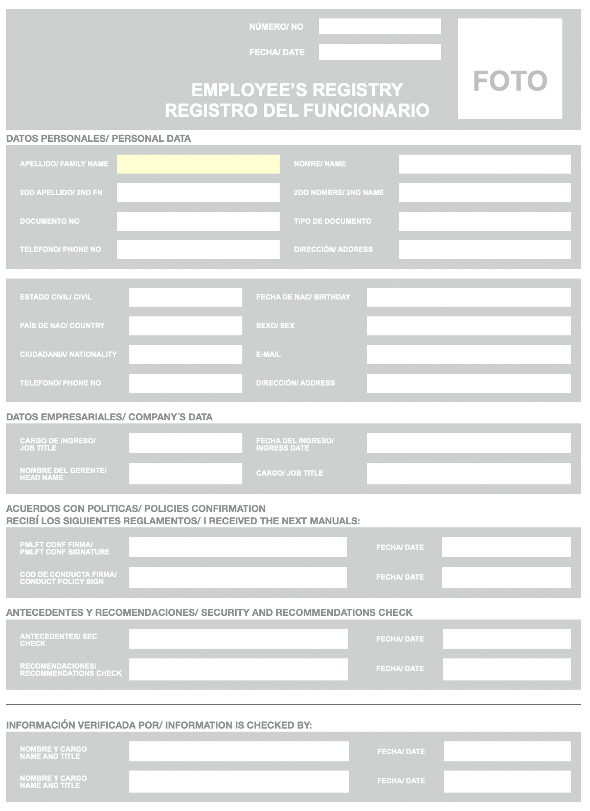

4.7. Customer registration form. Corporate customers

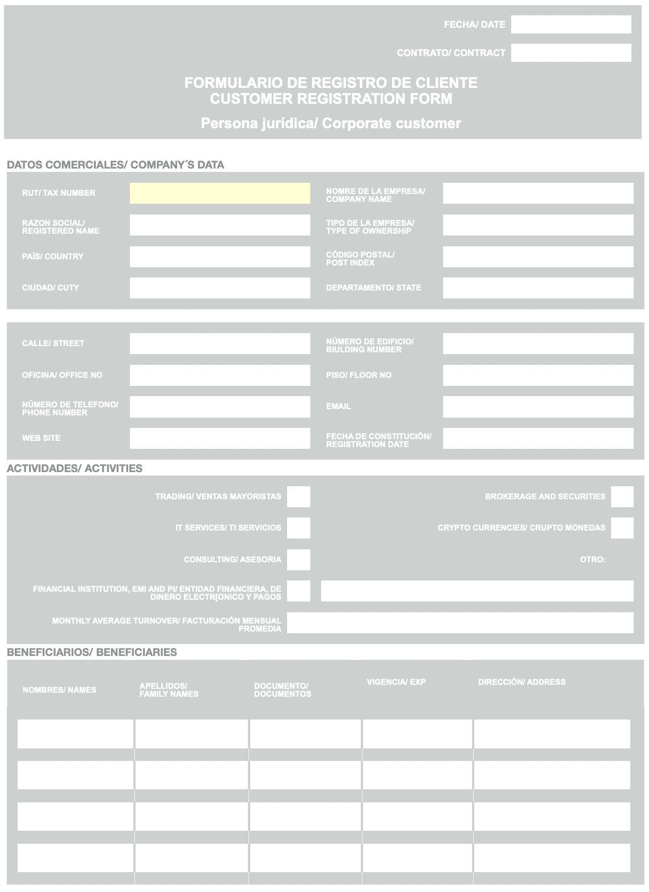
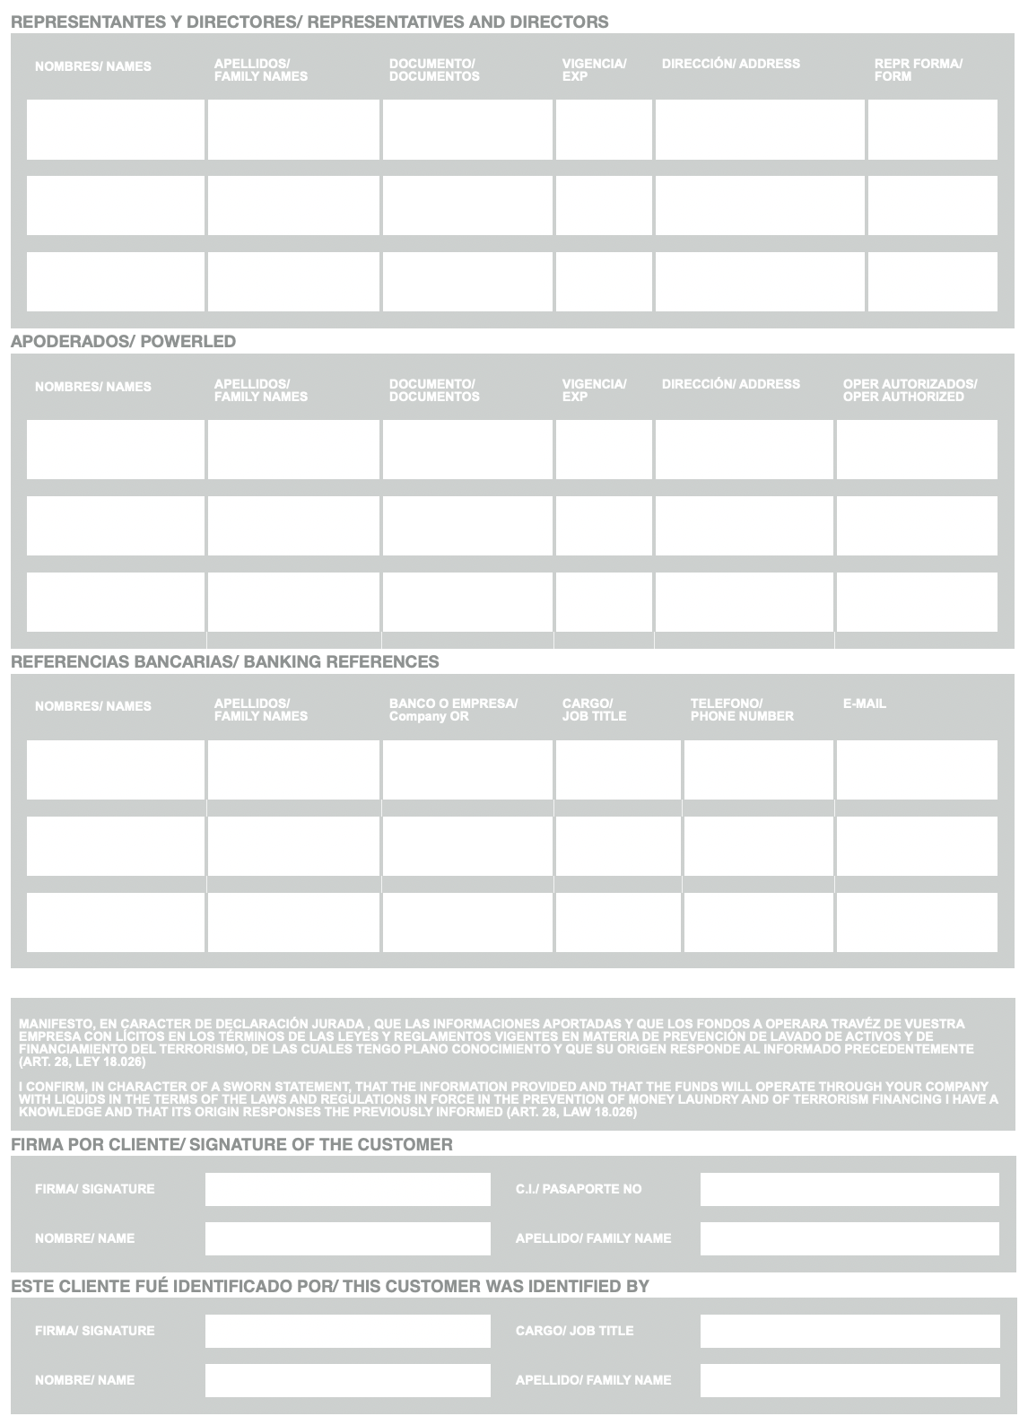

4.8. Declaration form of the beneficial owners of the company

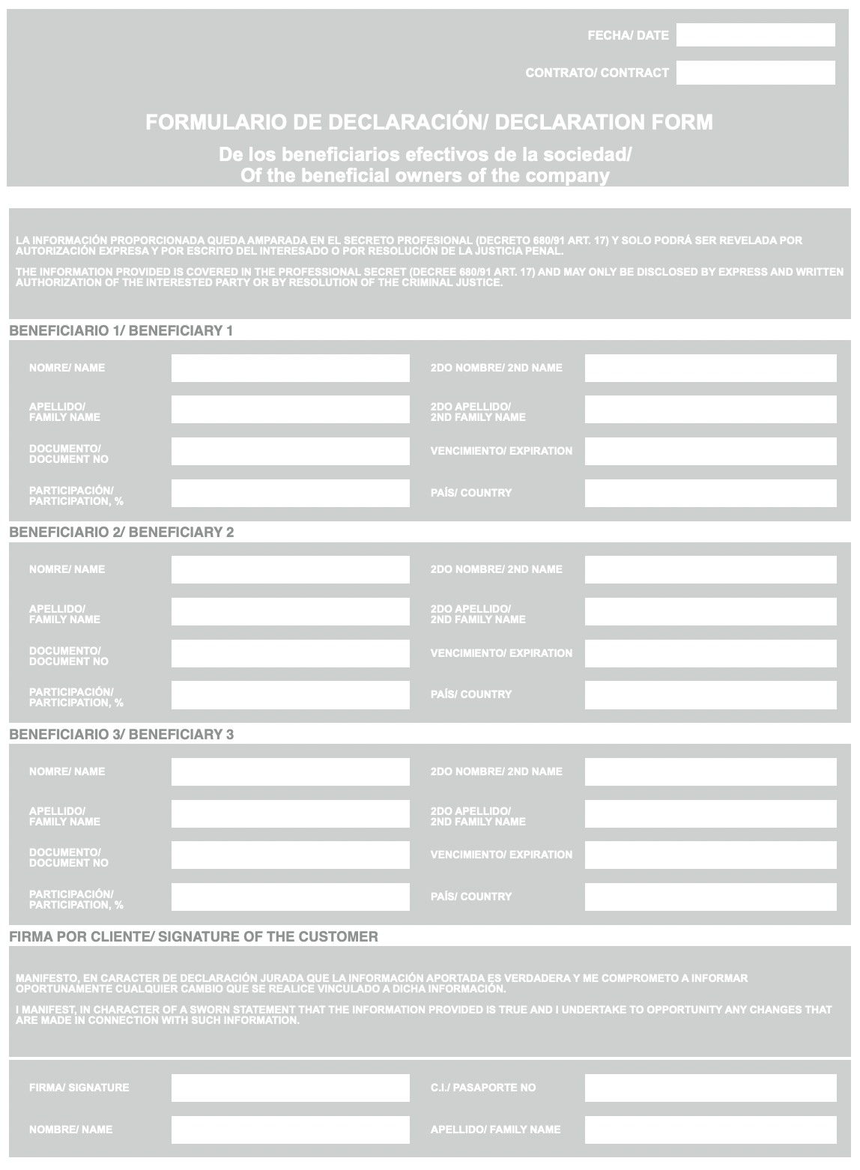

4.9. Declaration form of the funds origin

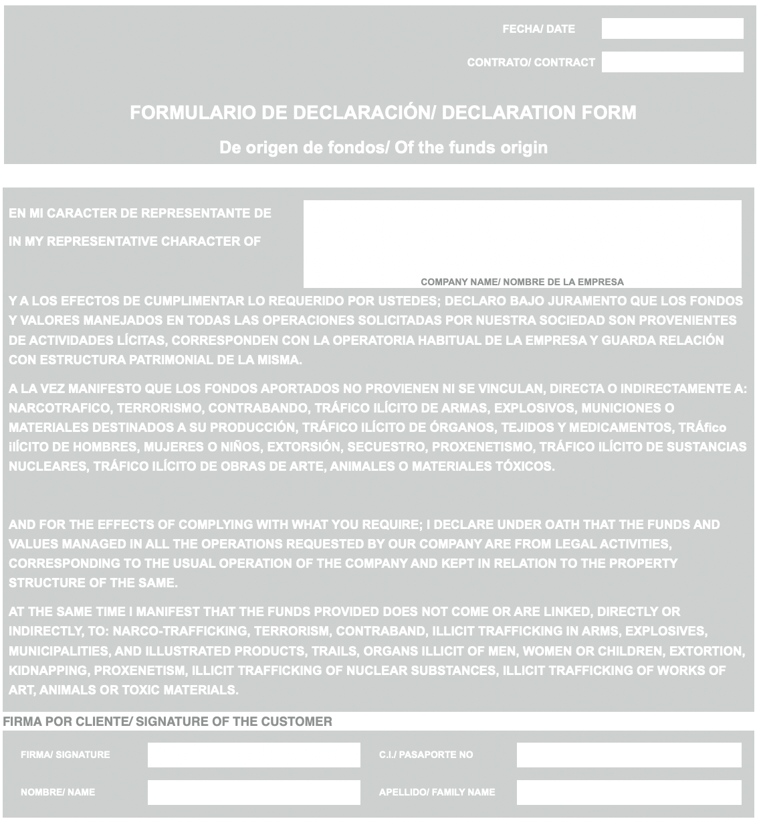

4.10. Suspicious transaction report

This report is made in online mode at the special resource of the council for financial activities control of Brazil.

In the case of the suspicious transaction found and on-line source doesn’t work, the Form below must be filled in and send to the council for financial activities control by mail.

FORM FOR REPORTING SUSPICION OF MONEY LAUNDERING
To be completed in Triplicate within 24 hours of transaction/encounter

CONFIDENTIAL COVER

council for financial activities control

Reference No:
Date: ______________________________________________
Date of Original Report: ___________________________________________
Code of Reporting Institution: ________________________________________________
Code of Reporting Officer: ____________________________________________
SUBJECT OF REPORT:
A: FOR INDIVIDUALS

Surname: _____________________________________
Forename: ____________________________________
Date of Birth: _________________________________
Nationality: ___________________________________

Identification Number: _________________________
1*. Address(es)
PO Box: _____________________________
_____________________________
Telephone No: _____________________________
Fax No.: _____________________________
E-Mail: _____________________________
PO Box: _____________________________
_____________________________
Telephone No: _____________________________
Fax No.: _____________________________
E-Mail: _____________________________
A: FOR OTHER LEGAL ARRANGEMENTS

Name: ________________________________________________

Number: ______________________________________
Business Address: ________________________________________________
________________________________________________
________________________________________________
Registered Office/Agent (if different): _________________________________________
_________________________________________
_________________________________________
Authorised signatory (ies):
Name(s) _______________________________________
Address (es) _______________________________________
_______________________________________
_______________________________________
Director(s)/Partners:/Nominees
Name(s) _______________________________________
Address (es): _______________________________________
_______________________________________
_______________________________________
Beneficial owner(s):
Name(s): _______________________________________
Address (es): _______________________________________
_______________________________________
_______________________________________
DETAILS OF IDENTIFICATION EVIDENCE HELD:
Identification Document: _______________________________________
Number: __________________________________
Date of Issue: __________________________________
Place of Issue: __________________________________
Name of other Company(s) or financial institution(s) involved in transaction*:

_____________________________________________________________________

Account number(s):
_____________________________________________________________________

Currency (ies):
_____________________________________________________________________
Reason for Suspicion:
(Please include the name and amount of the transaction(s), the source and determination of funds, and the reason for the suspicion. Attach additional pages if necessary.

Transaction completed Yes ______ No ___

Other Relevant Information:

For what reason did you consider this transaction to be suspicious?

Signed by: (name of compliance officer and/or other senior officer)

Reported by:
SIGNATURE POSITION DATE

Received by:
SIGNATURE POSITION DATE

4.11. Declaration form of the verification the veracity of the data provided

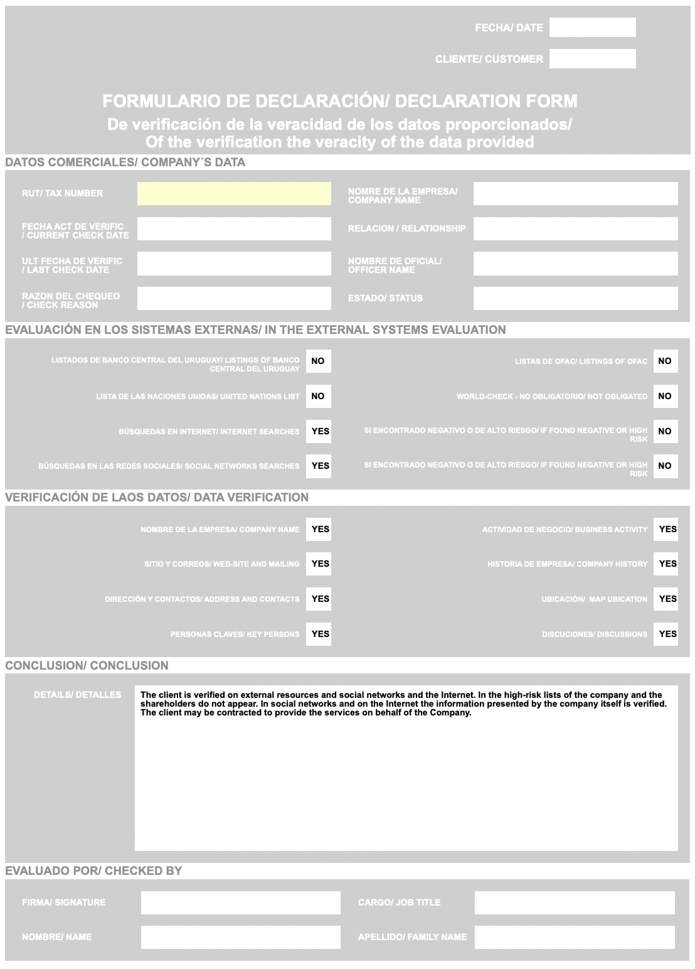
A. EVIDENCIAS/
A. evidencES

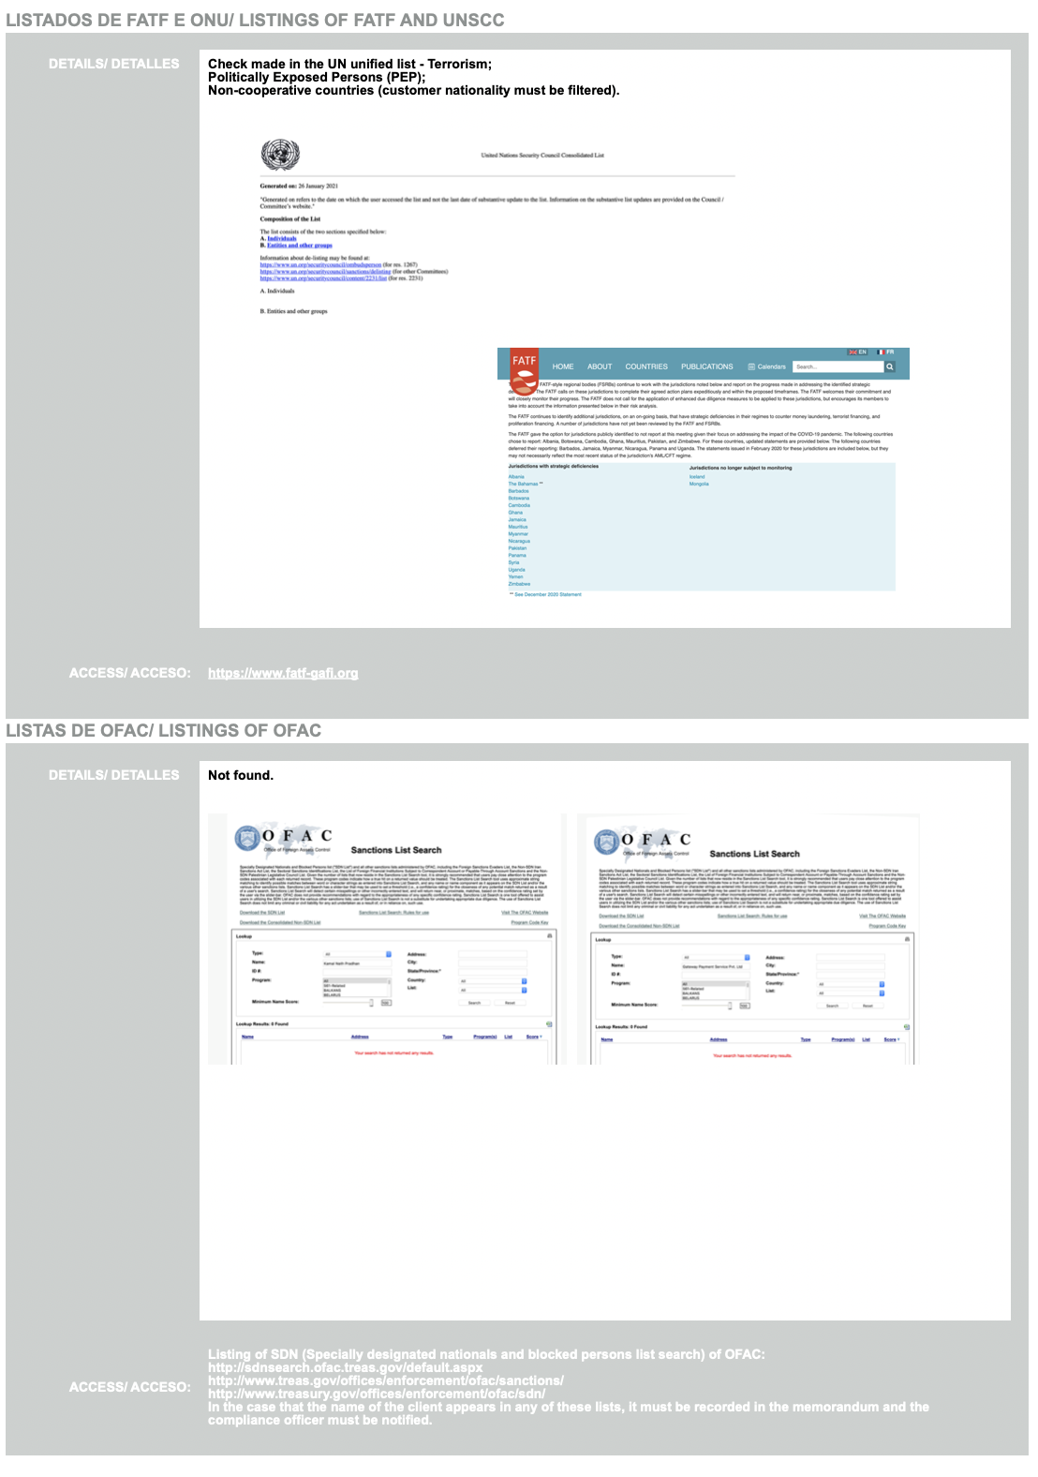
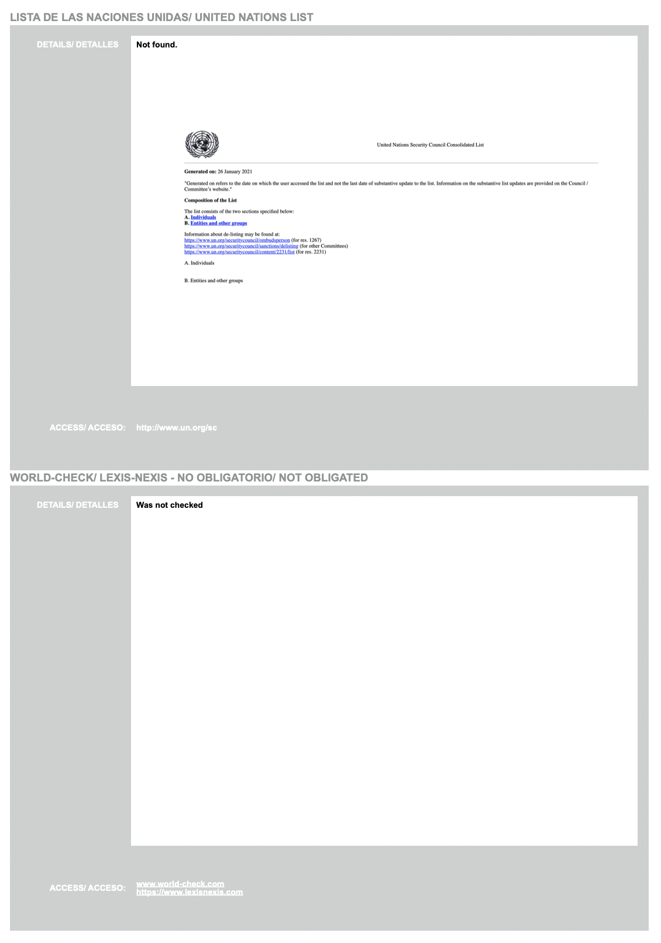

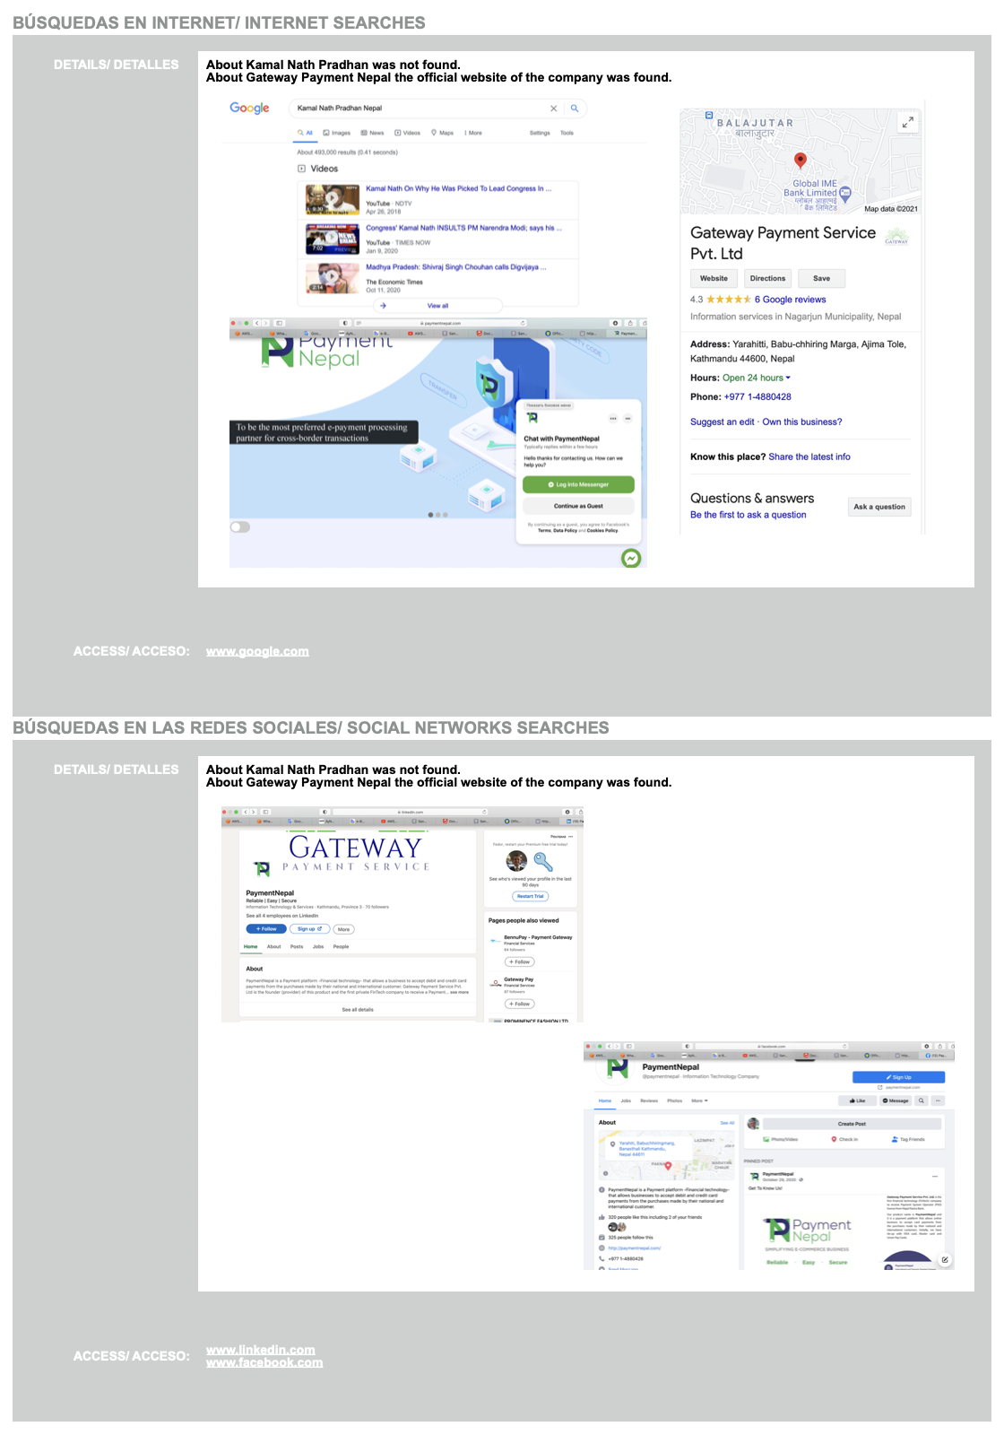

4.12. Declaration form of the risks evaluation

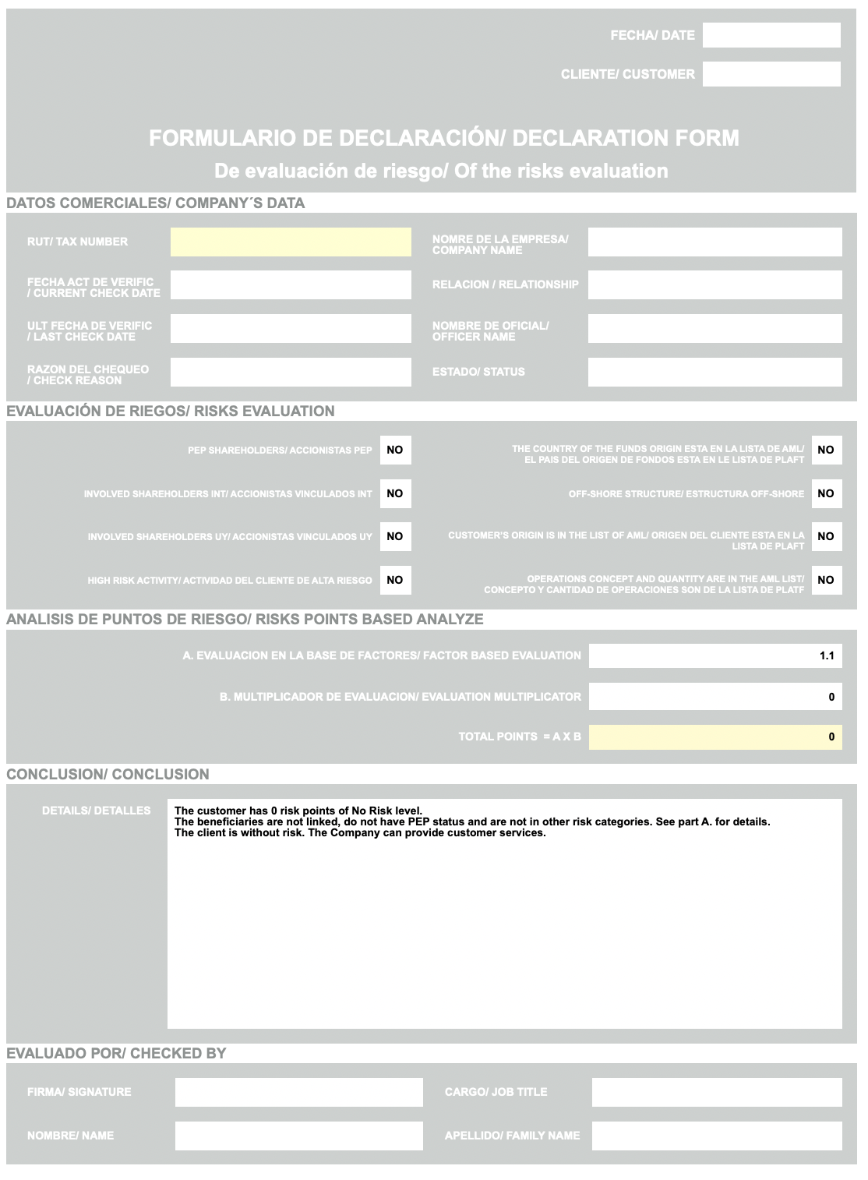

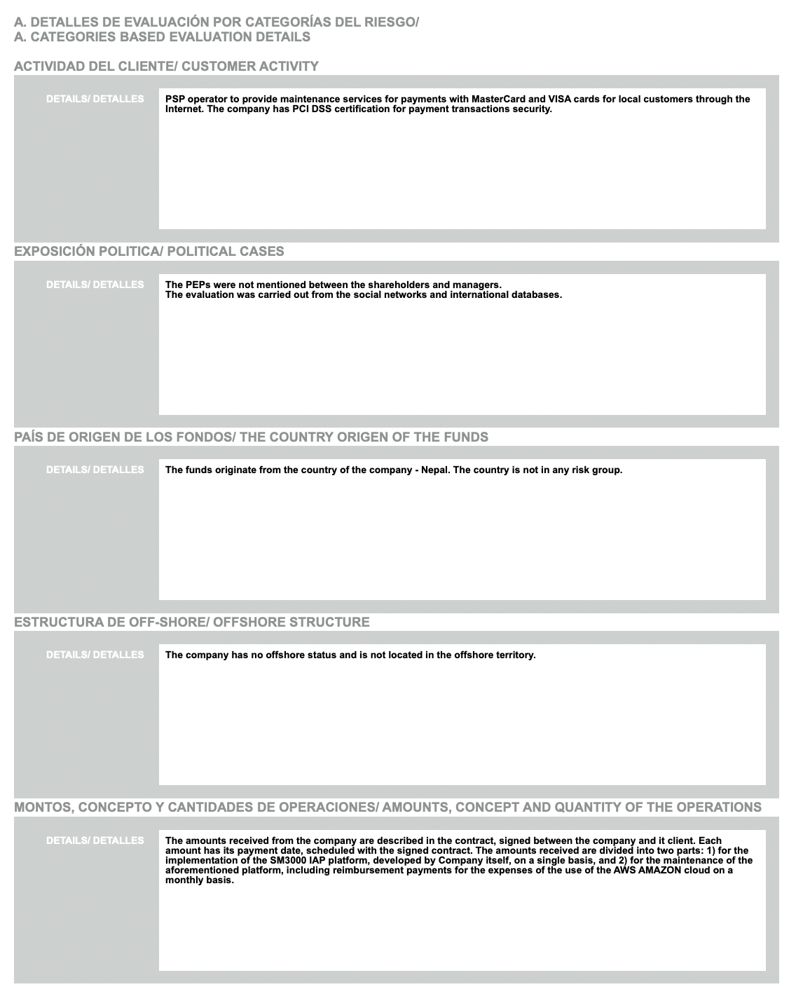

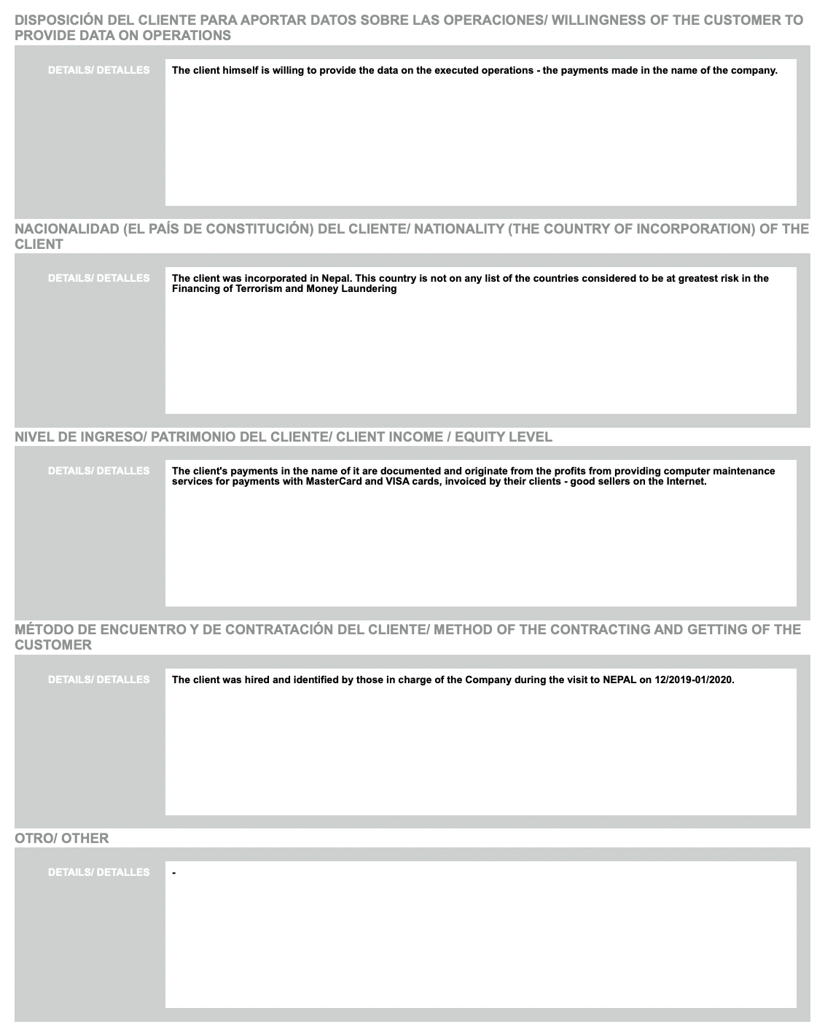
B. MATRIZ DE EVALUACION DE RIESGO DEPENDE DE FACTORES/
B. RISK EVALUATION MATRIX BASED ON FACTORS

N | Factor | Low |  | Medium |  | High |  | Coefficient, depends on the amount * | Assigned Risk
 |  | Explanation | P | Explanation | P | Explanation | P | Coefficient, depends on the amount * | Points
1 | Knowledge of the Client / Age of the relationship with the client | Direct knowledge of the Client. Knowledge of the client more than 2 years | 0 | The client was referred by a contact of the entity/Knowledge of the Client less than 2 years | 5 | N/A | 0
 |  |  | 0 | There is no prior knowledge of the client / Knowledge of the client for less than 1 year | 15
2 | Source of Funds | Funds transferred from banking institution | 0 | Funds transferred from exchange institution | 20 | Funds transferred from another type of institution | 20
3 | Territorial Jurisdiction | Countries not included in the following categories | 0 | Afghanistan, Bosnia-Herzegovina, Iraq, Guyana, Laos PDR, Syria, Uganda, Vanuatu and Yemen Countries BONT, Belarus, Venesuela, Russian Federation | 20 | North Korea, Iran | 50
4 | Identification/Validation/Control over final beneficiaries | Simple structures (Individuals and legal entities with direct BF natural persons) | 0 | Complex structures (vehicle companies) | 15 | Complex structures in which the final beneficiary is difficult to identify or verify. Examples: Trust, Foundations, others. | 50
5 | Type of business or economic activity | Activities not included in the following categories | 0 | Hotels and travel agencies. Marketers/lessors of motor vehicles, boats and aircraft. Builders. Marketers or real estate agencies. Gas Stations. Companies located in free zones. | 20 | Clients that handle third-party fundsCasinos, gaming halls and racetracks, Remitters of fundsNon-Governmental Organizations, Manufacturers, dealers and distributors of arms, Dealers and distributors of precious metals, Antiquities dealers  Auction Houses Travel Agencies Public Real Estate Auctioneers  Soccer clubs, soccer contractors and related activities. exchange houses | 50
6 | Political exposure level | The client is not a PEP | 0 | Client has PEP relatives | 20 | The client is a PEP or was in the last 5 years | 50
7 | Linked people | N/A | 0 | The client is a person linked to the institution | 20 | N/A | 0
 | risk margin | < 20 |  | > 20 |  | > 50

C. MATRIZ DE CATEGORIZACIÓN DE RIESGO/
C. RISK categorization MATRIX

Amount | No risk, <20 points * |  | At risk, >20 points * |  | PEPs, >50 points *
 |  | Coefficient |  | Coefficient |  | Coefficient
> usd 1,500,000 | Extreme | 2 | Extreme | 2 | Extreme | 2
usd1,000,000 - 1,500,000 | High | 1.2 | Extreme | 2 | Extreme | 2
usd 100,000 - 1,000,000 | Medium | 1.1 | High | 1.2 | Extreme | 2
usd 50,000 - 100,00 | Low | 1.0 | Medium | 1.1 | Extreme | 2
usd 10,000 - 50,000 | Low | 1.0 | Low | 1.0 | Extreme | 2

4.13. The countries which have signed the Memorandum of Understanding and are presently members of CFATF and the 6 Co-operating and Supporting Nations

Members of the Caribbean Financial Action Task Force
(membership is subject to change):

Anguilla Guyana
Antigua & Barbuda Republic of Haiti
Aruba Jamaica
The Bahamas Montserrat
Barbados The Netherlands Antilles
Belize Nicaragua
Bermuda Panama
The British Virgin Islands St. Kitts & Nevis
The Cayman Islands St. Lucia
Costa Rica St. Vincent & The Grenadines
Dominica Suriname
The Dominican Republic The Turks & Caicos Islands
El Salvador Trinidad & Tobago
Grenada Venezuela
Guatemala

The Cooperating and Supporting Nations are:

Canada France
The Netherlands United Kingdom
United States of America Spain

